COMPARATIVE PROGRAMMING LANGUAGES CSET 4250

FINAL REPORT

ADHVIKA IYER

Table of Contents

Screenshots: 2

Flowcharts 17

Project Summary: 21

Student Grading Application 21

History and Overview: 22

Python 22

Tkinter 22

Comparison between languages 23

1. Readability 23

2. Writability 23

3. Reliability 24

4. Cost 24

Illustrations and Explanations of Python features used: 25

1. Syntax 25

2. Control Structures 25

3. Data Structures 26

4. I/O 26

5. Parameter Passing Methods 26

6. Scope Rules 27

7. Stack/Heap - Constructors/Destructors 27

8. Error Handling Procedures 27

9. Data Abstraction 34

Code: 35

Python and Tkinter GUI 35

Scripting Code-Powershell 45

# ***Screenshots:***

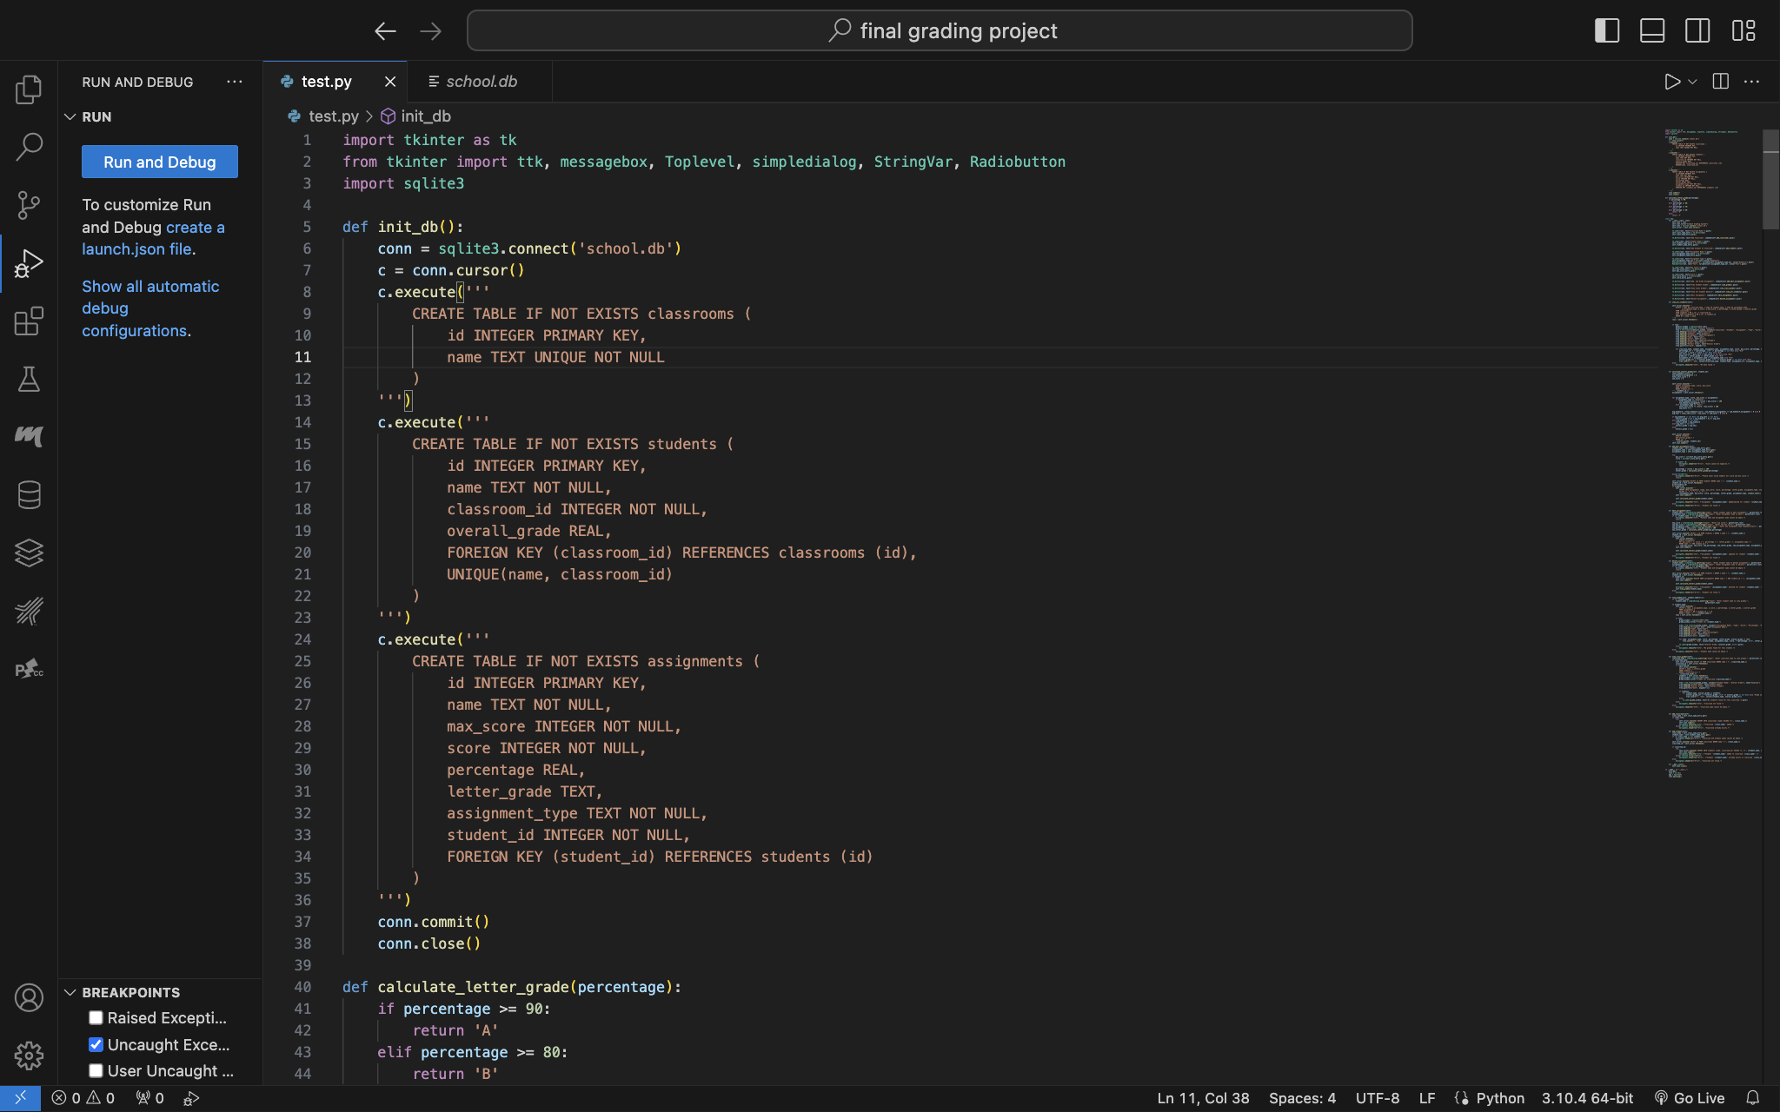

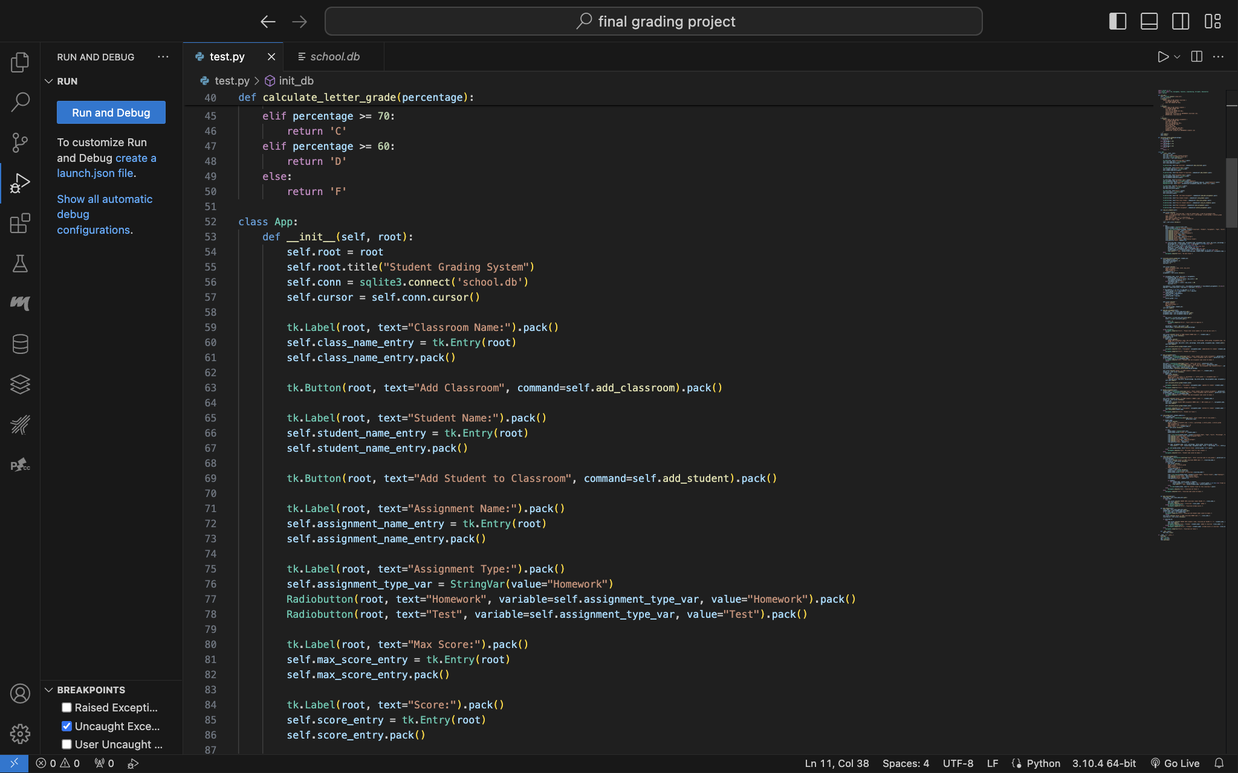

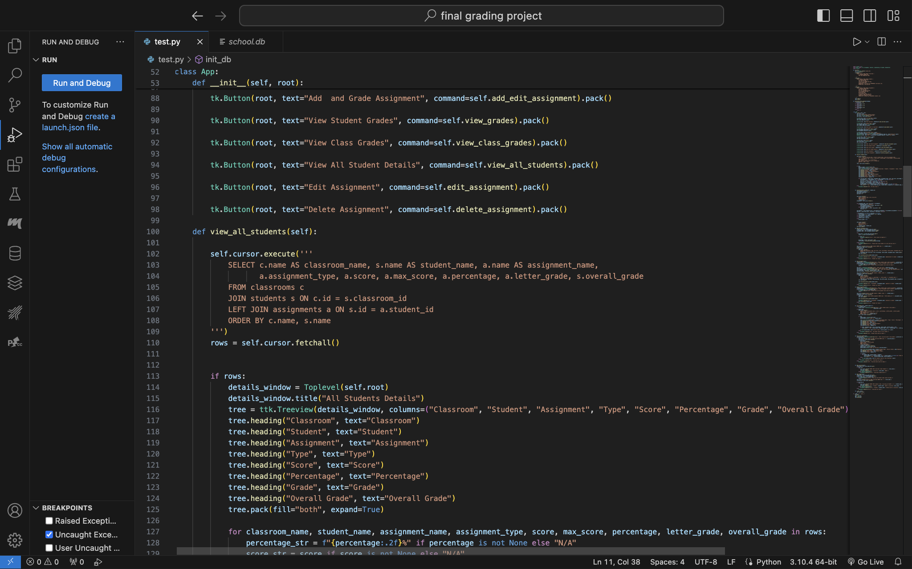

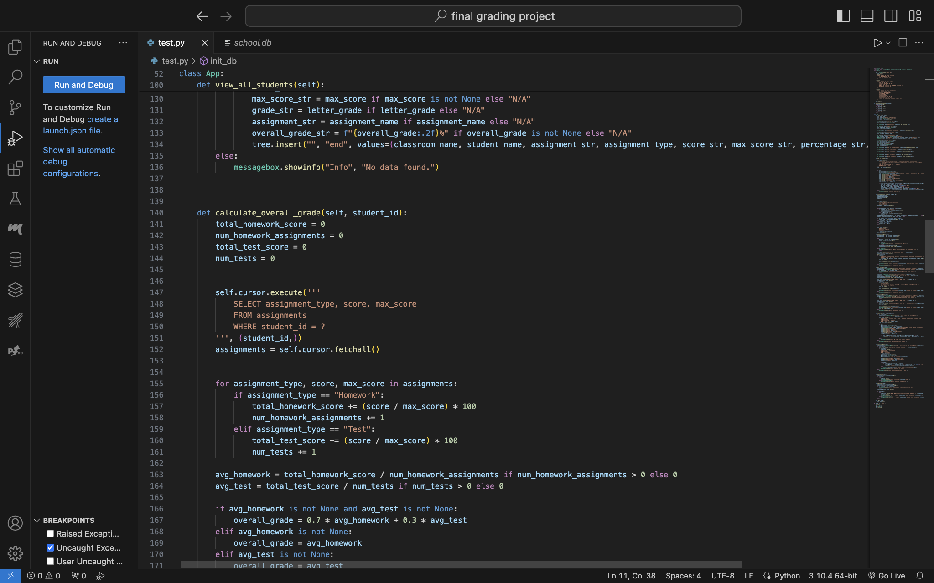

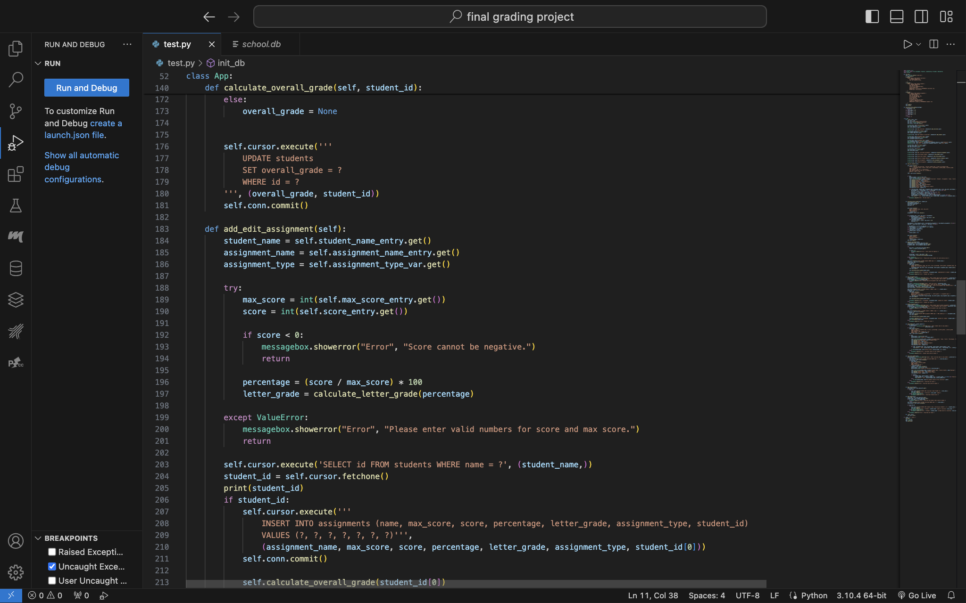

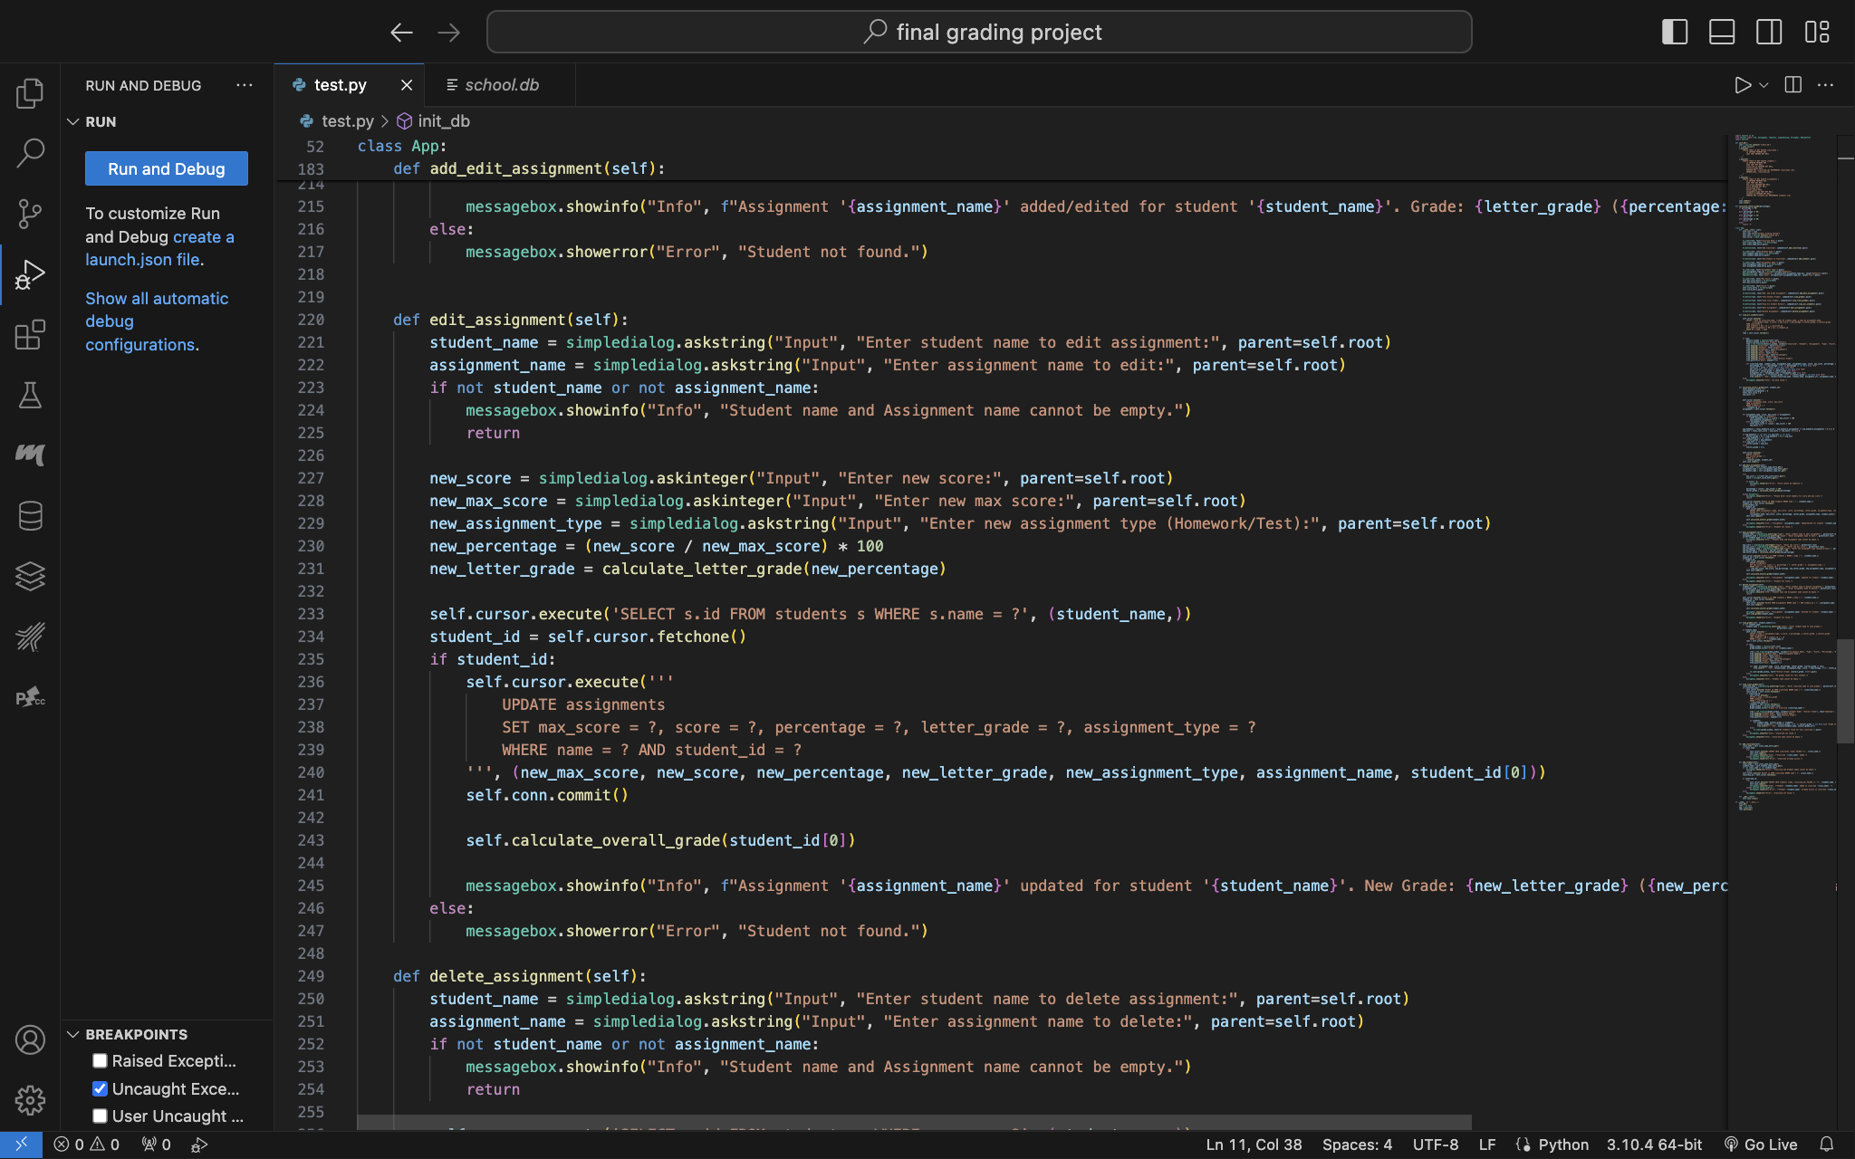

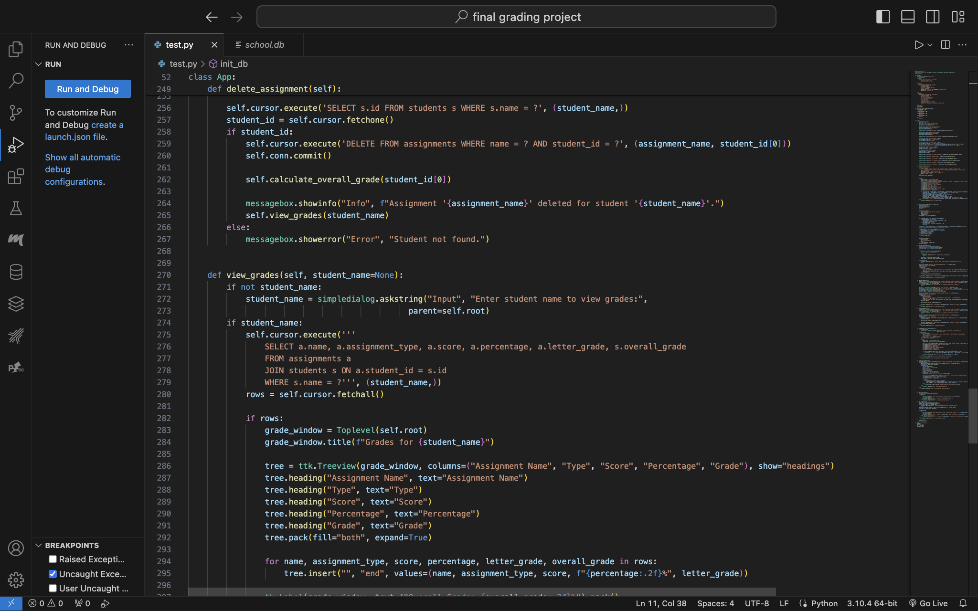

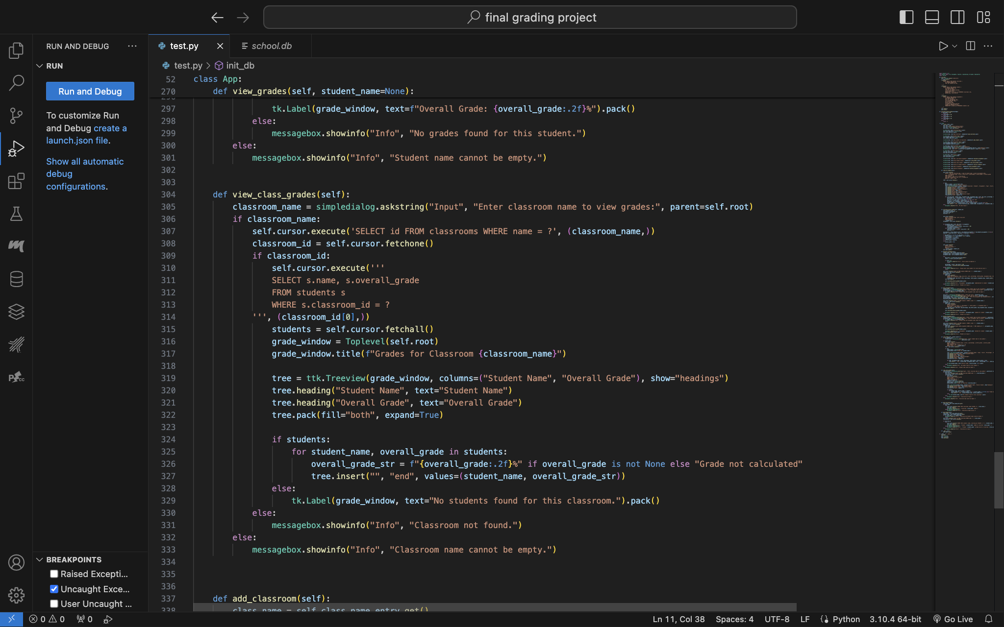

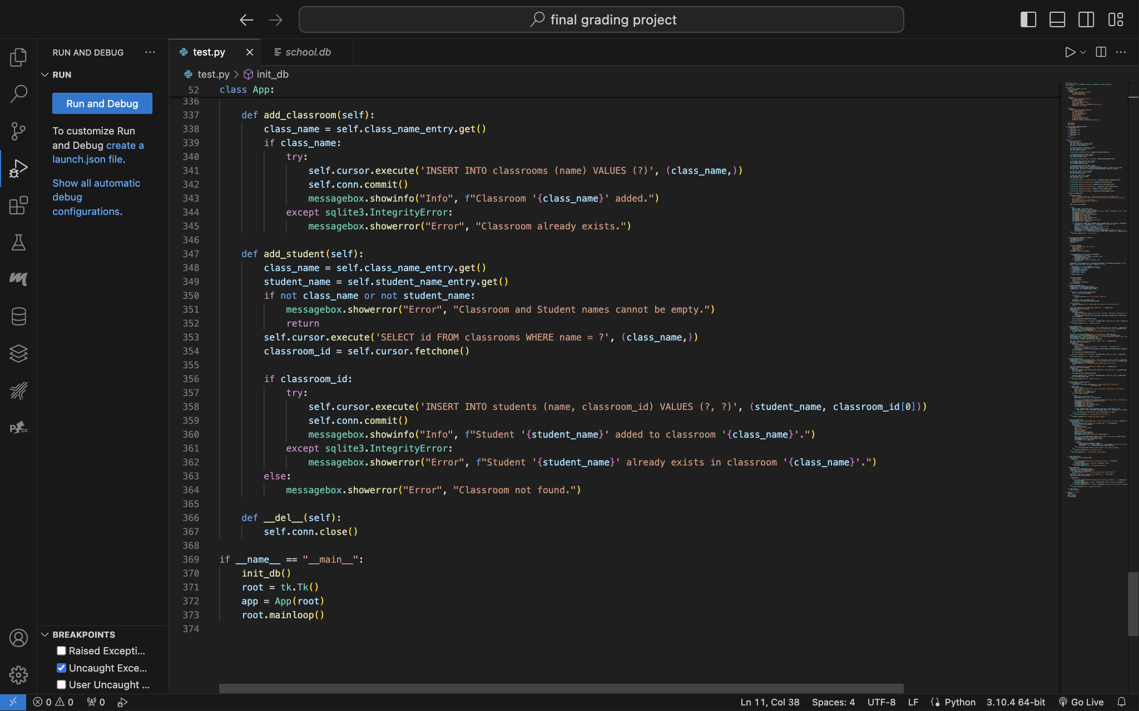

Application GUI:

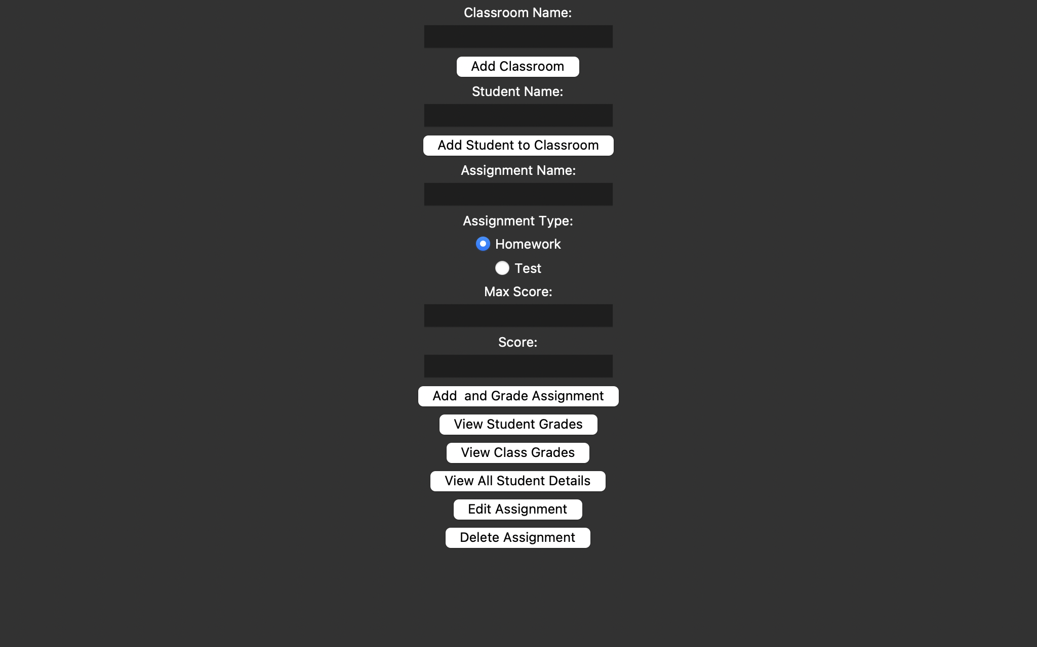

Adding Class:

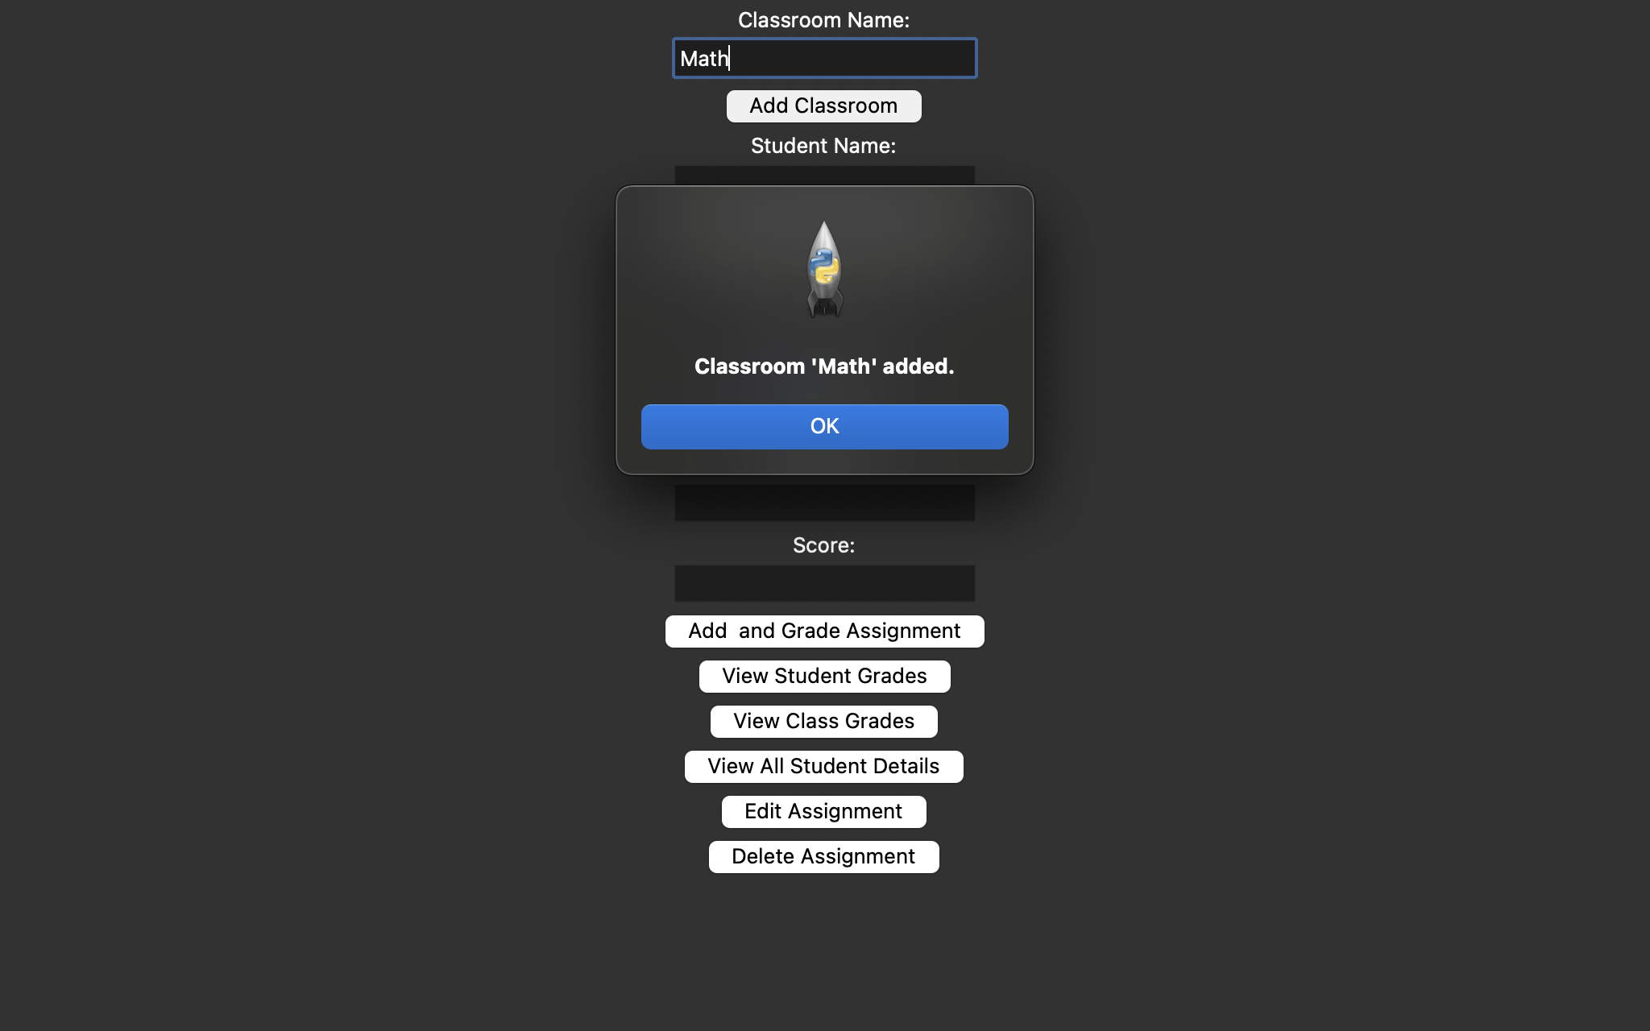

Adding Student to class:

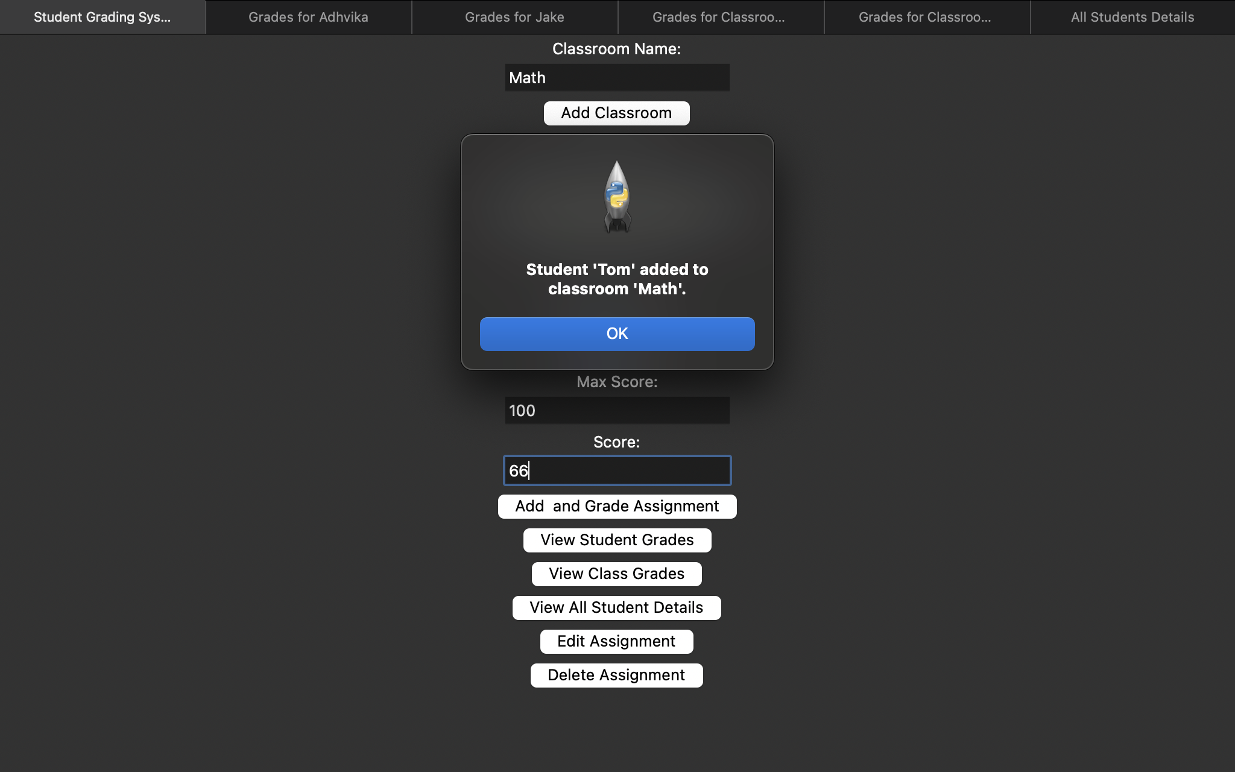

Entering score and max score and defining the type of assignment: Homework or Test after clicking “Add and Grade assignment” button we get this:

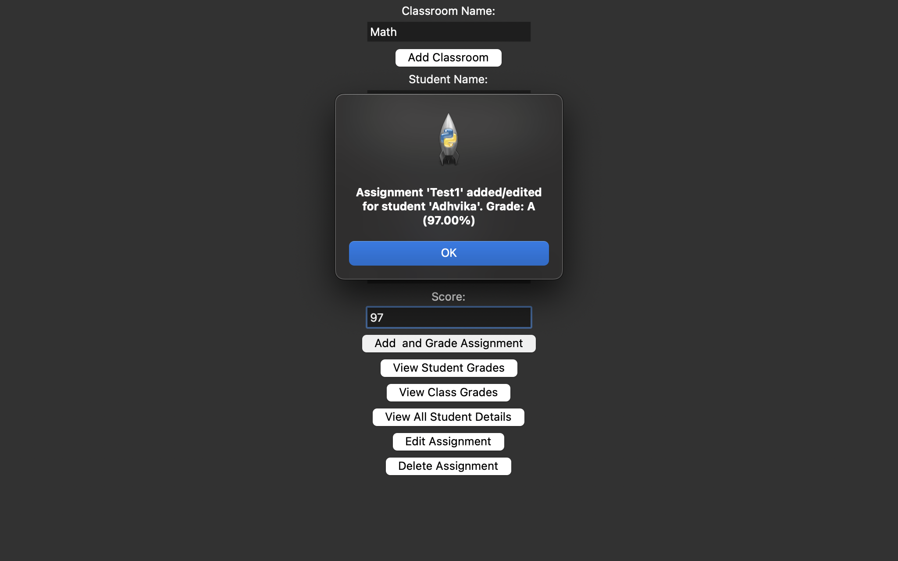

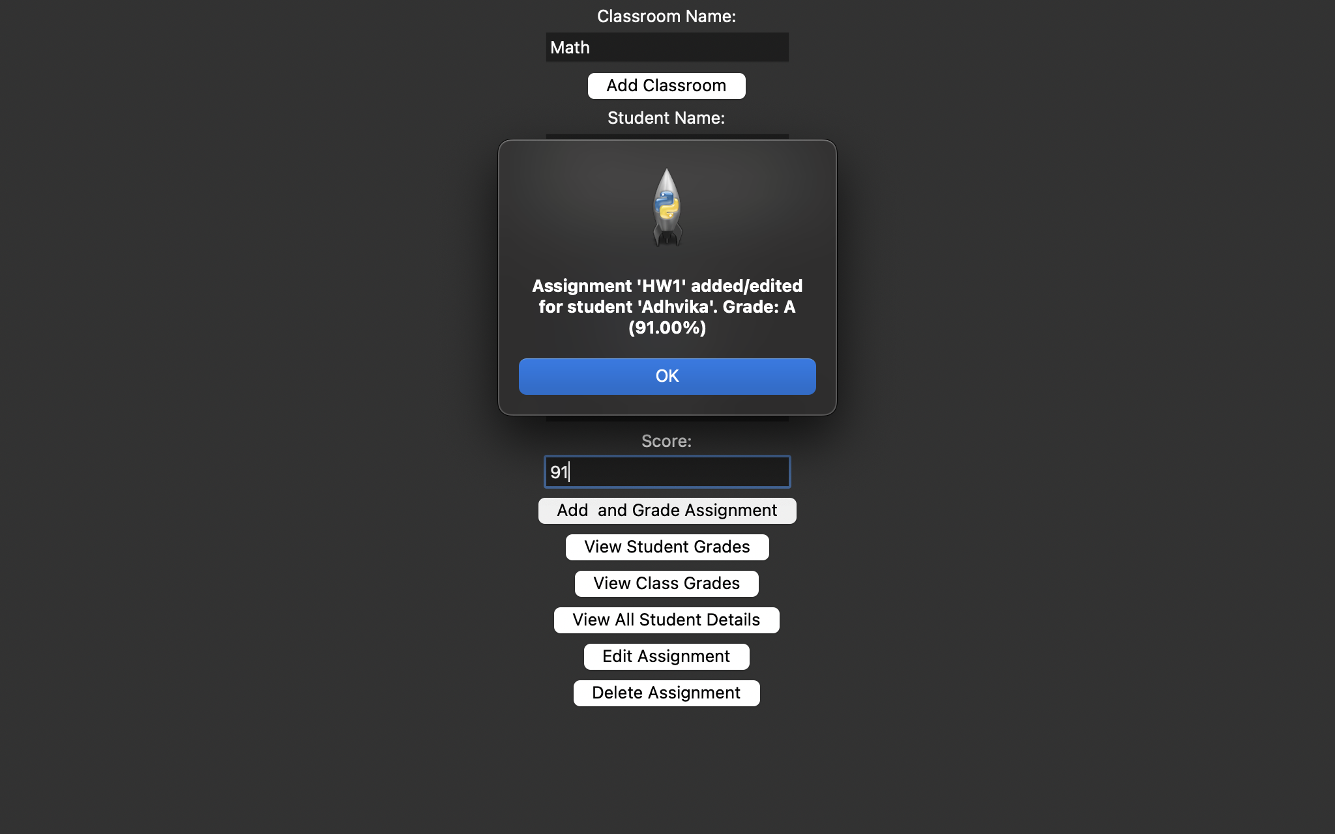

The button “ view student grades” allows us to enter a particular student’s name and gives us their grade for all assignments, letter as well as percentage grade and gives us their overall grade too:

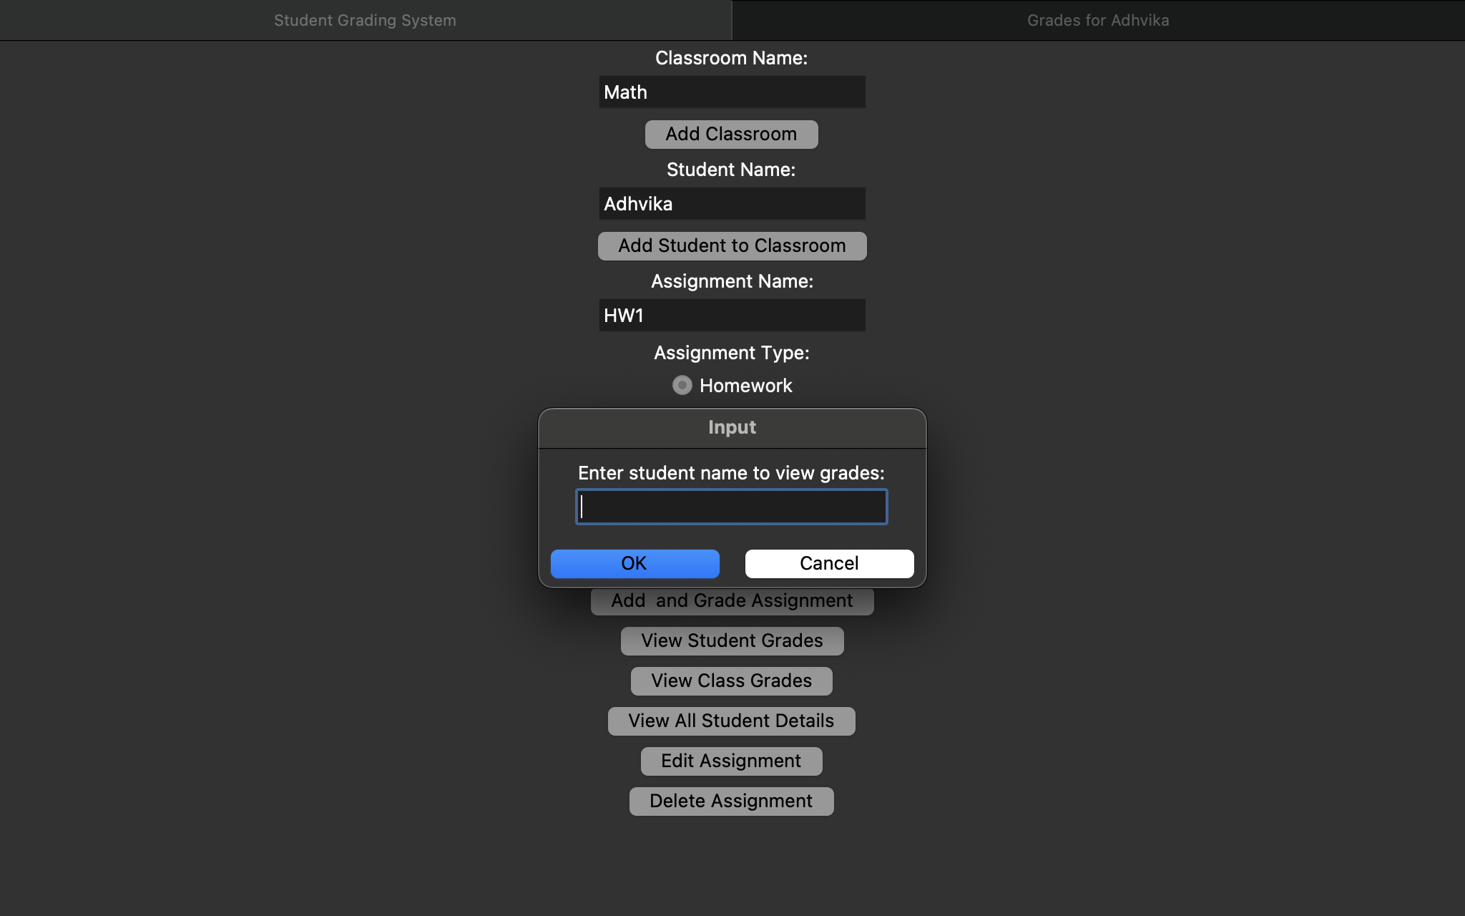

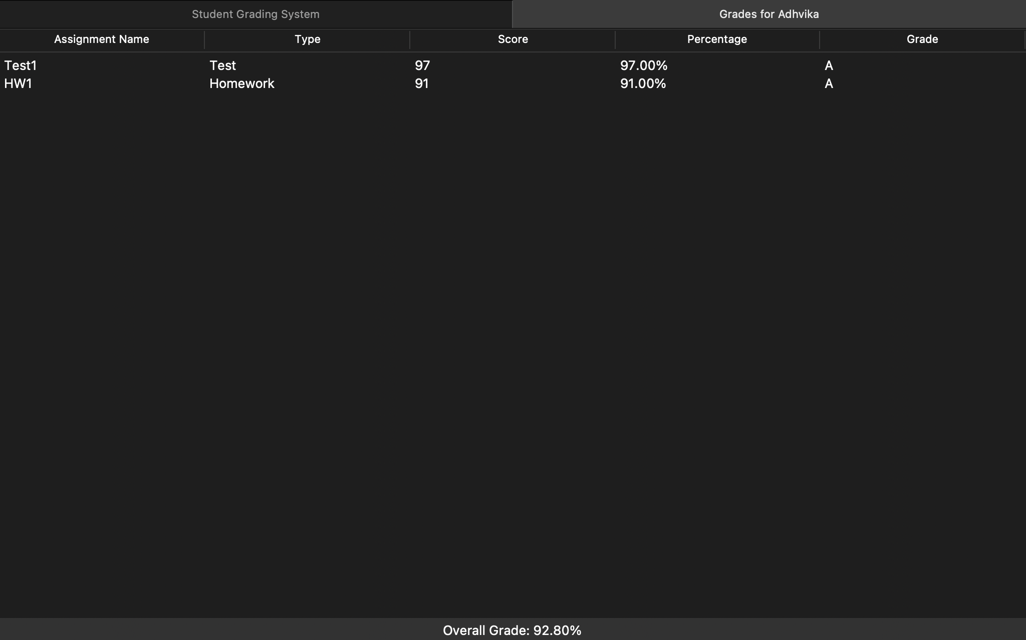

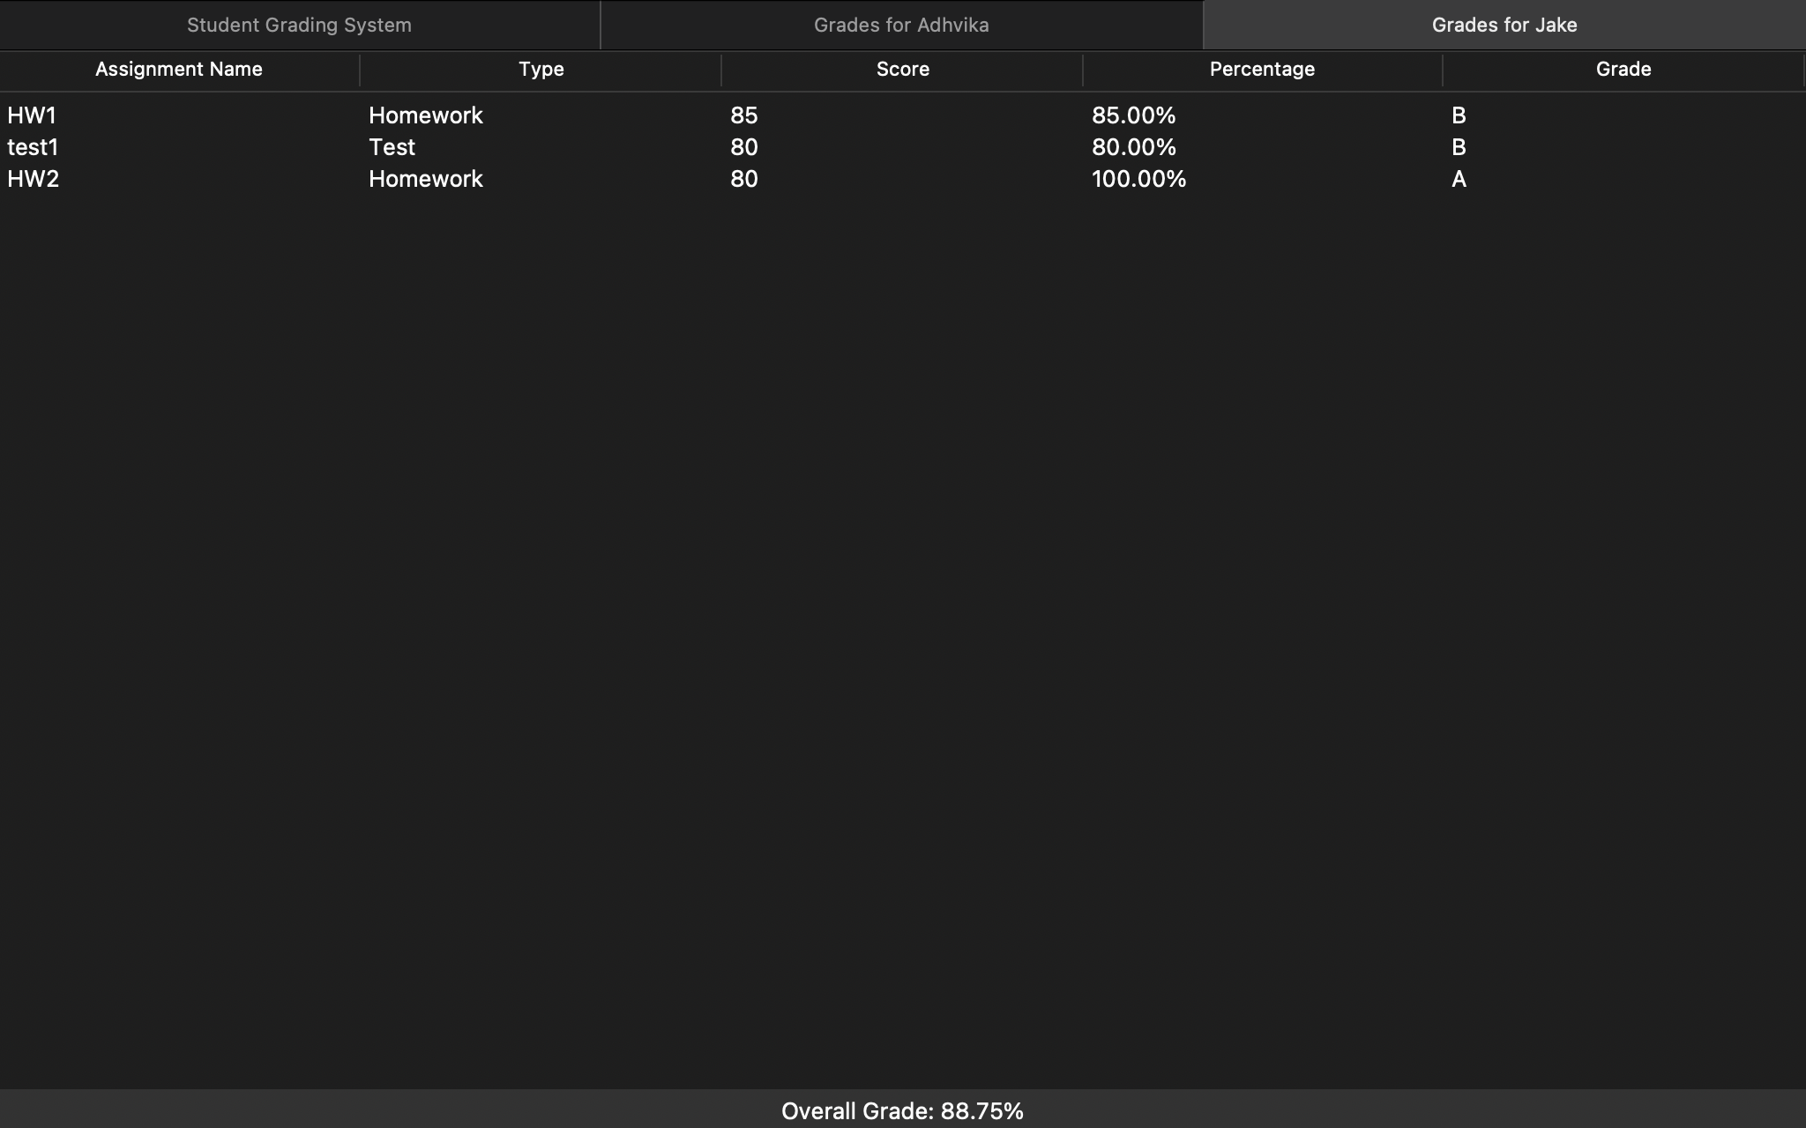

We can then use the button “View class grades” to view grades of students class-wise that is view the grades of all students enrolled In a particular class:

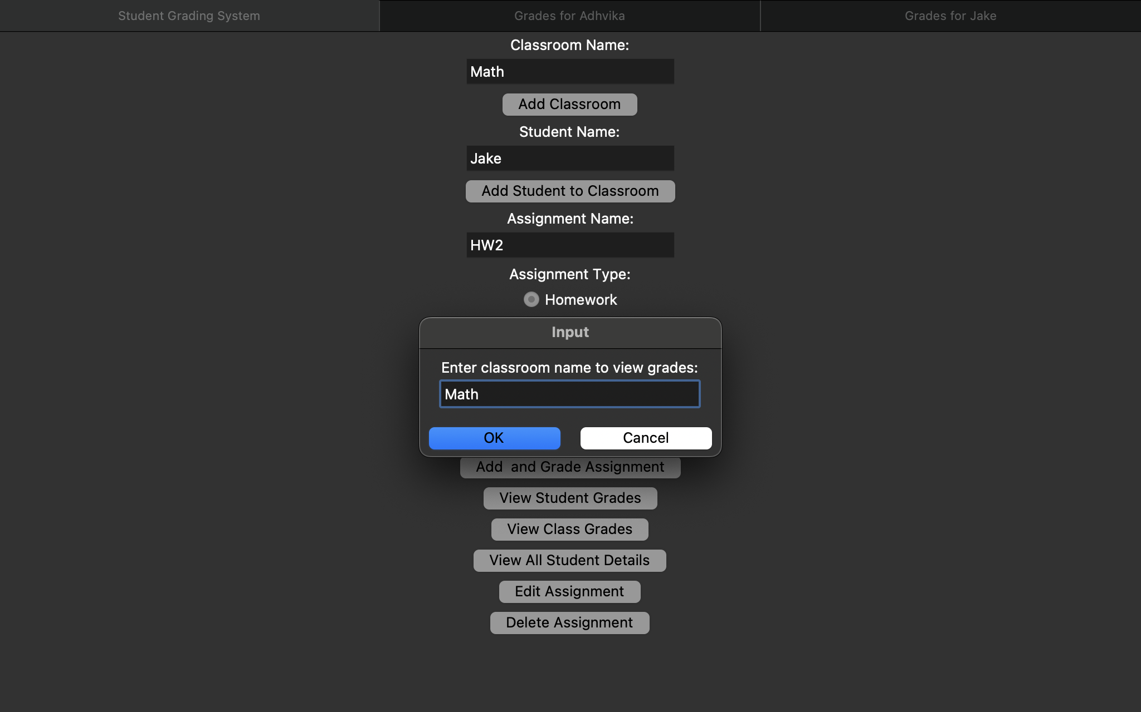

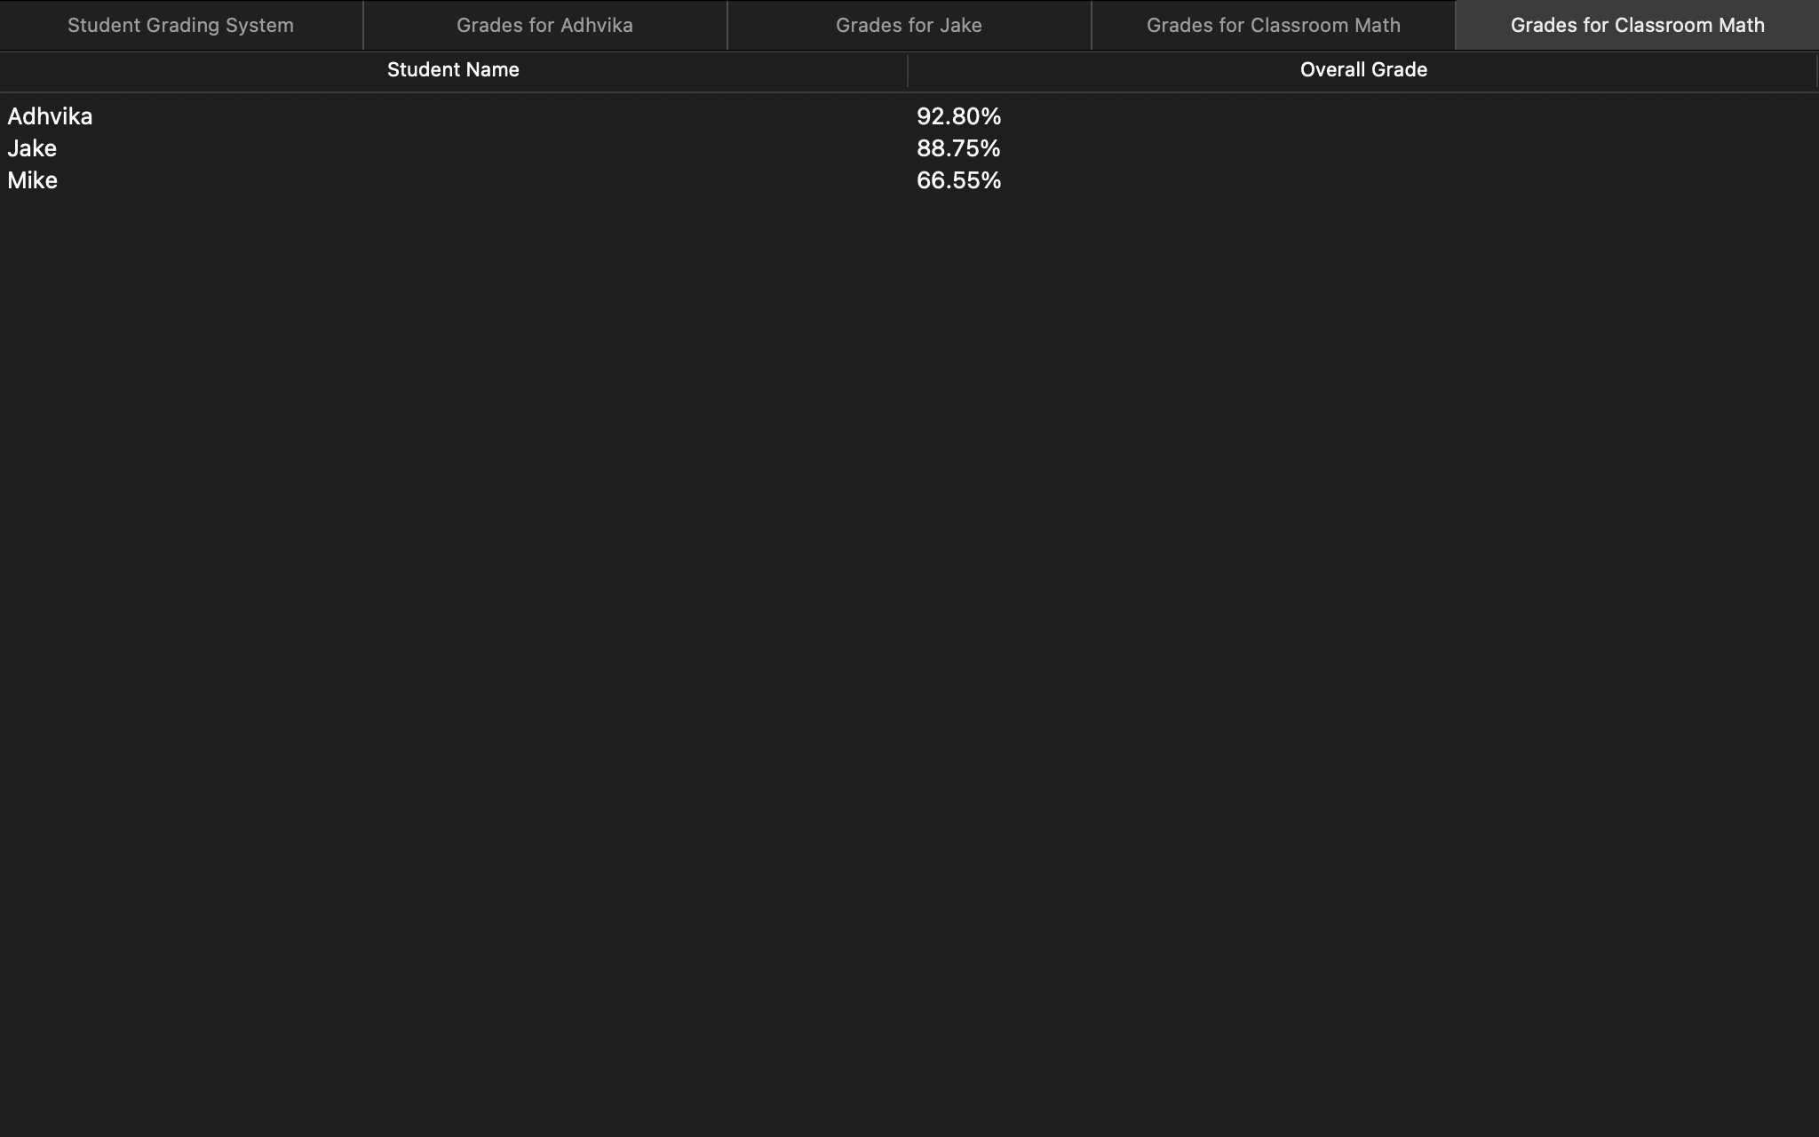

As and when we enter our data all of it is getting stored in a database, the button “View All student details” basically displays all the data that is being stored in our database in real time

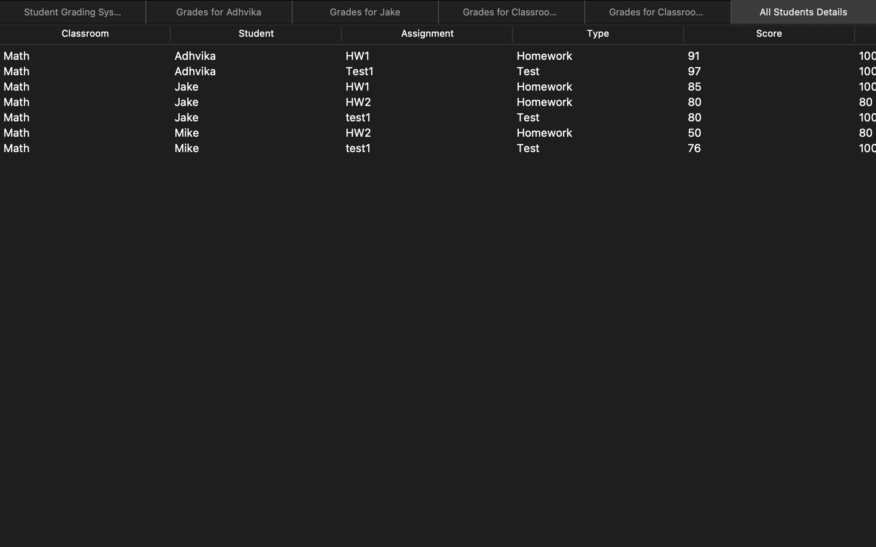

Now we can use the Edit option to edit a particular assignment’s scores for a particular student by entering their name, name of the assignment and making changes if we want to the max score and score received by the student. We also get an option to redefine the type of assignment it is: Homework or Test:

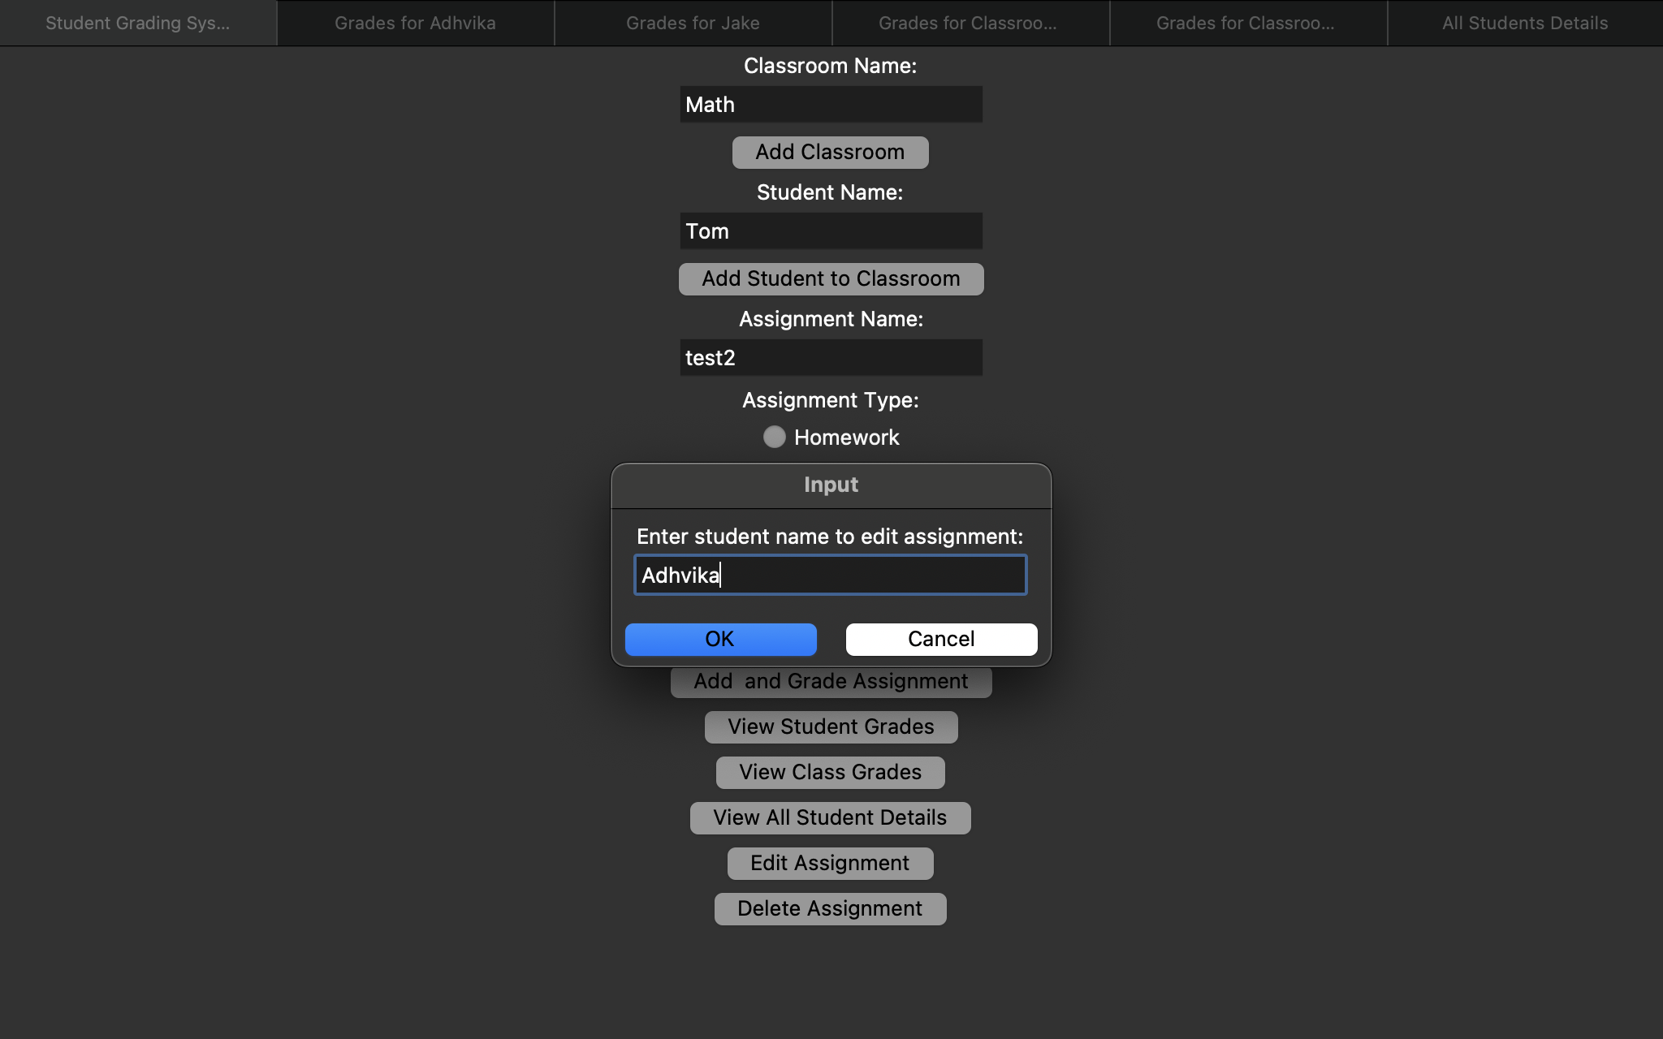

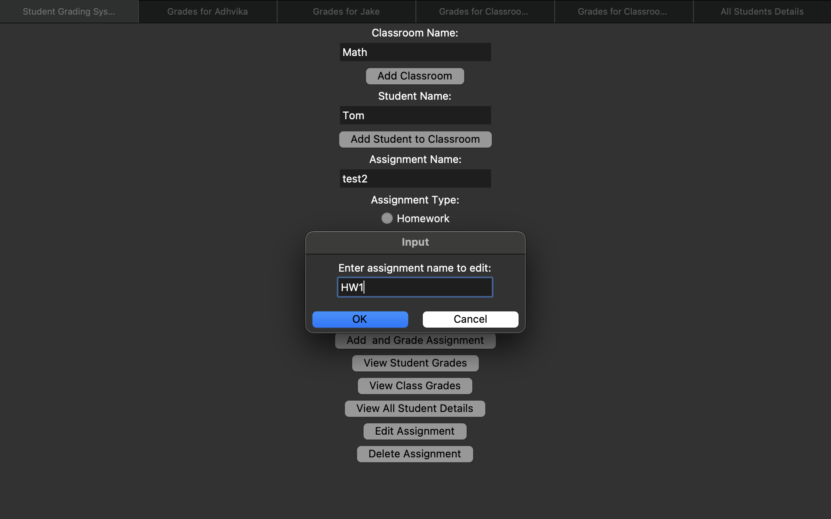

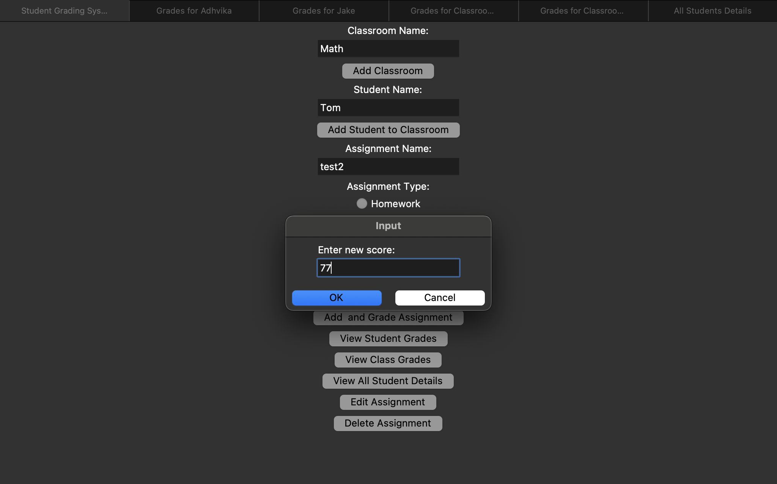

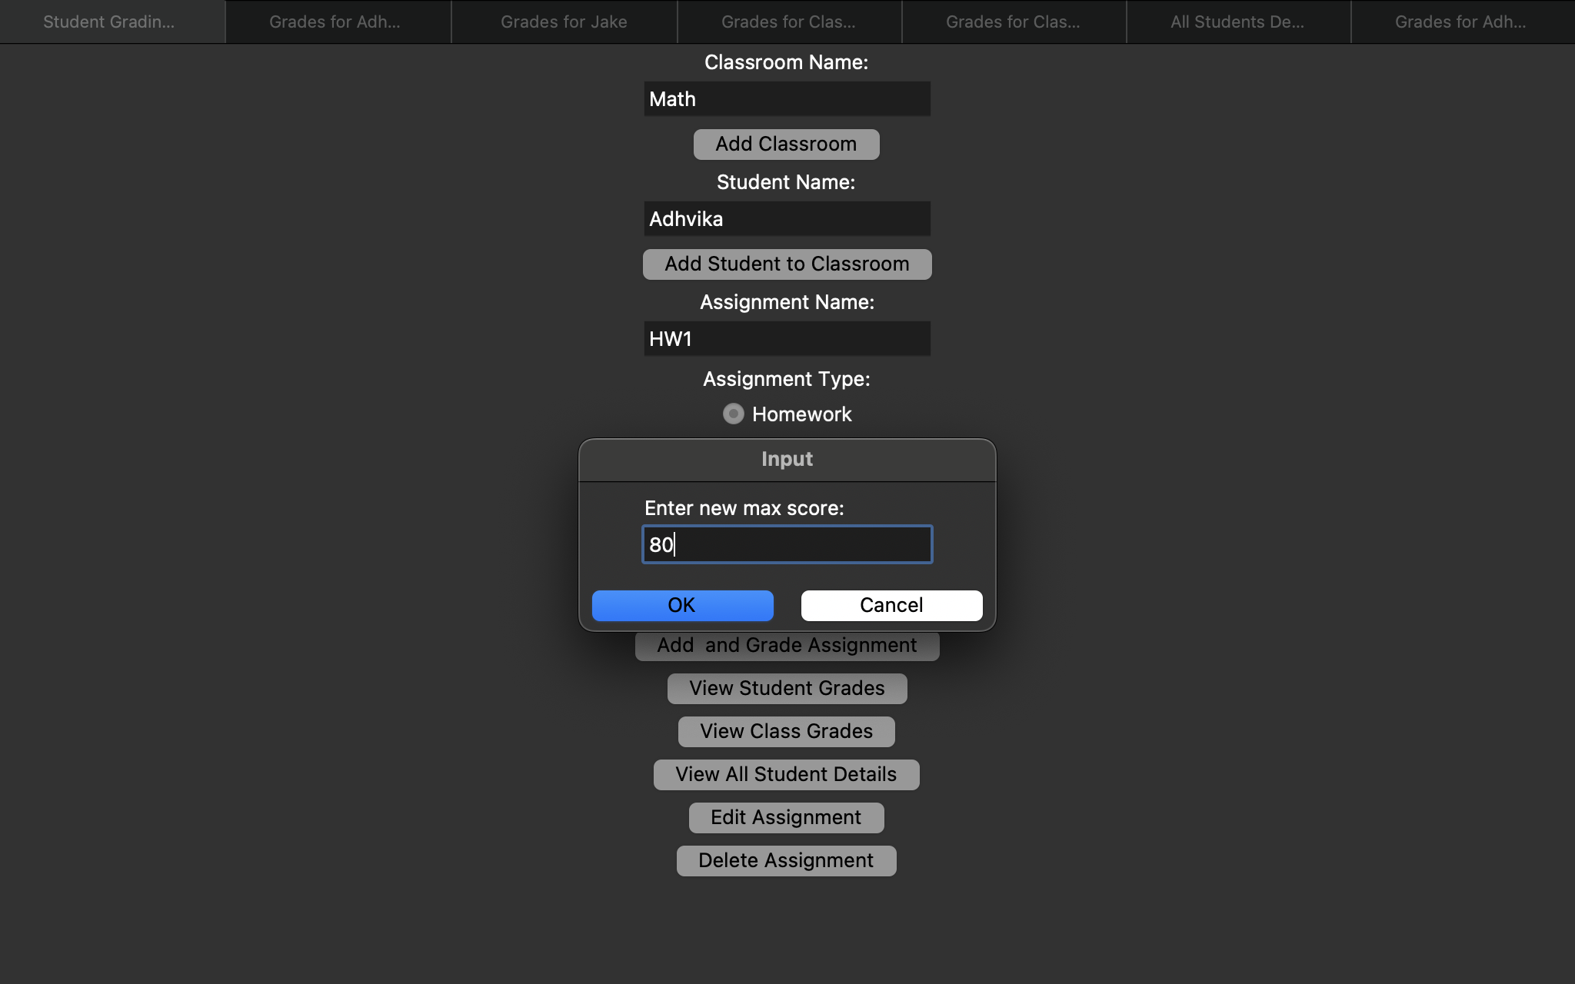

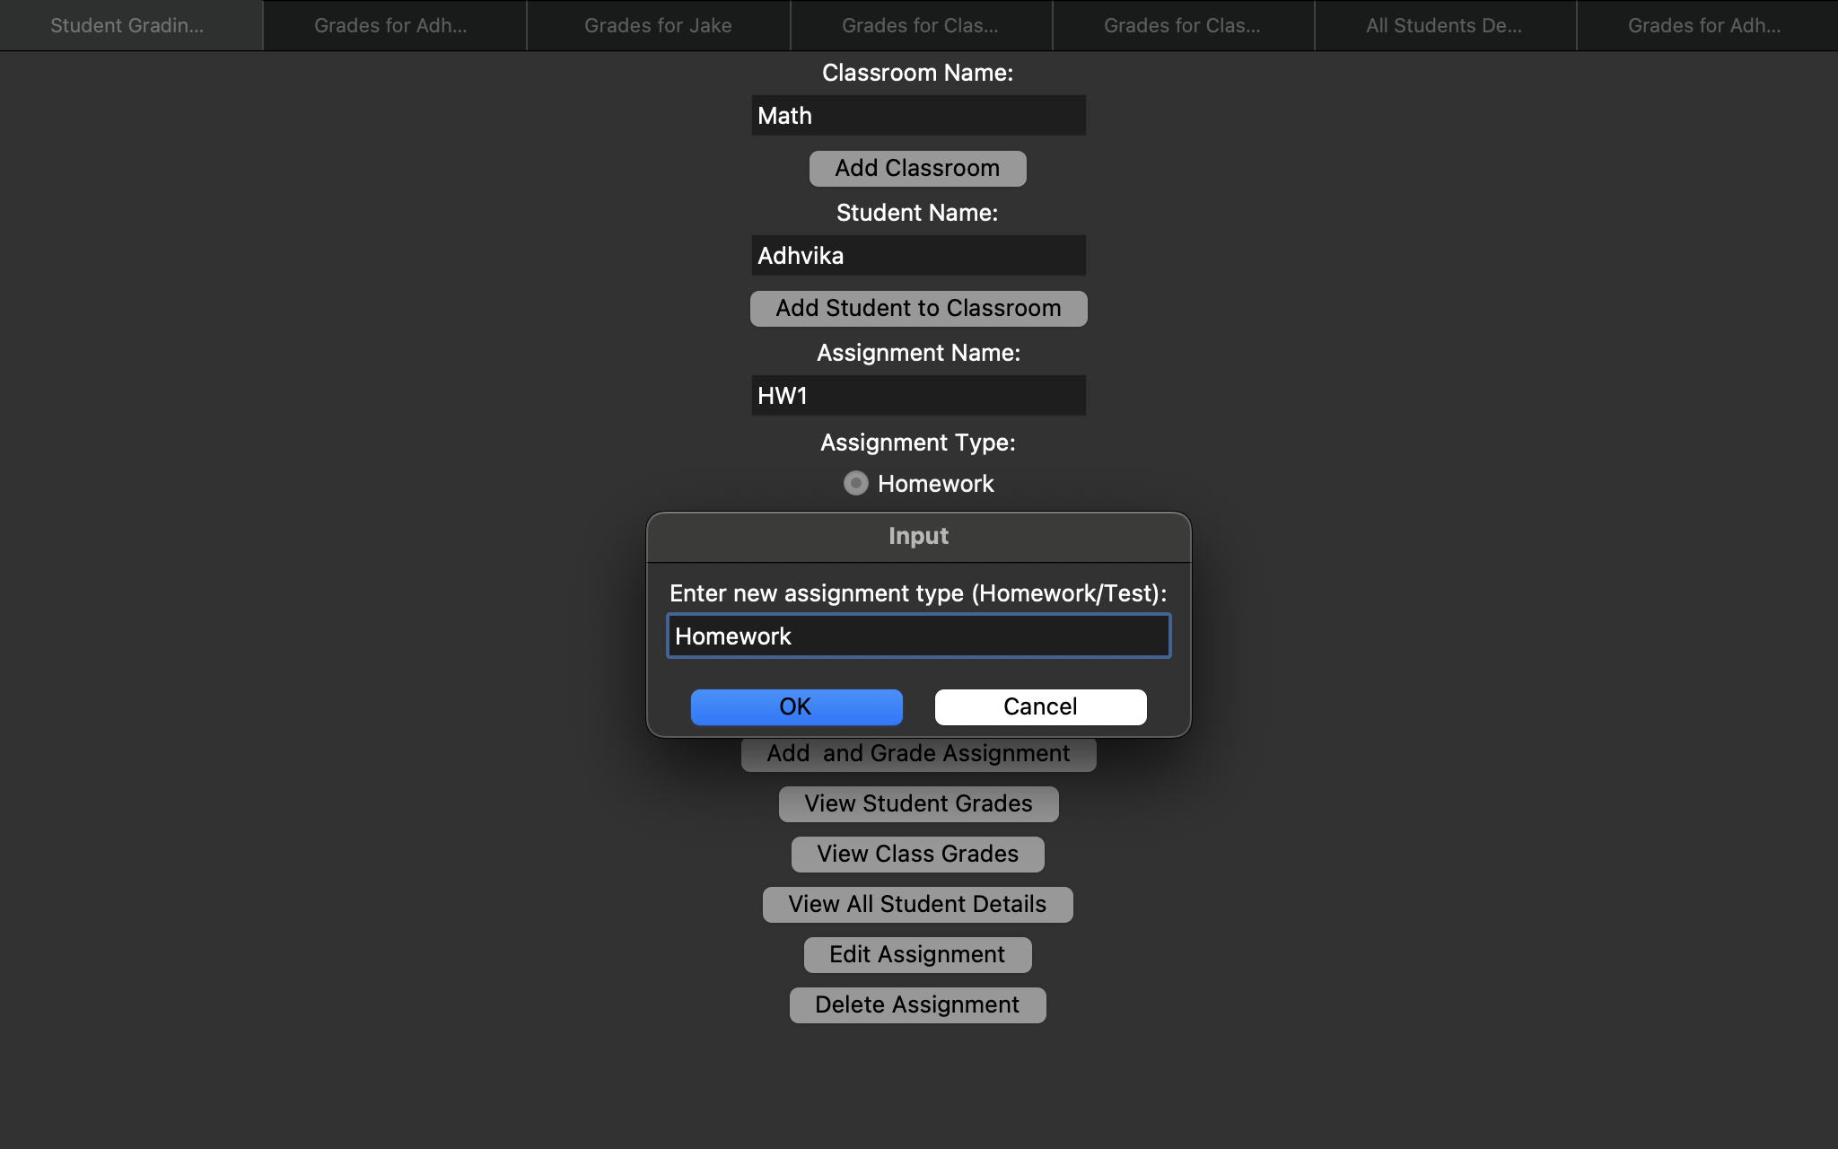

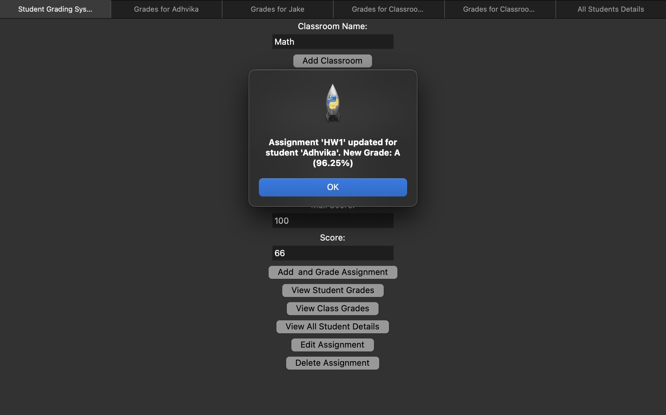

The “delete assignment” button allows us to delete a particular assignment of a particular student:

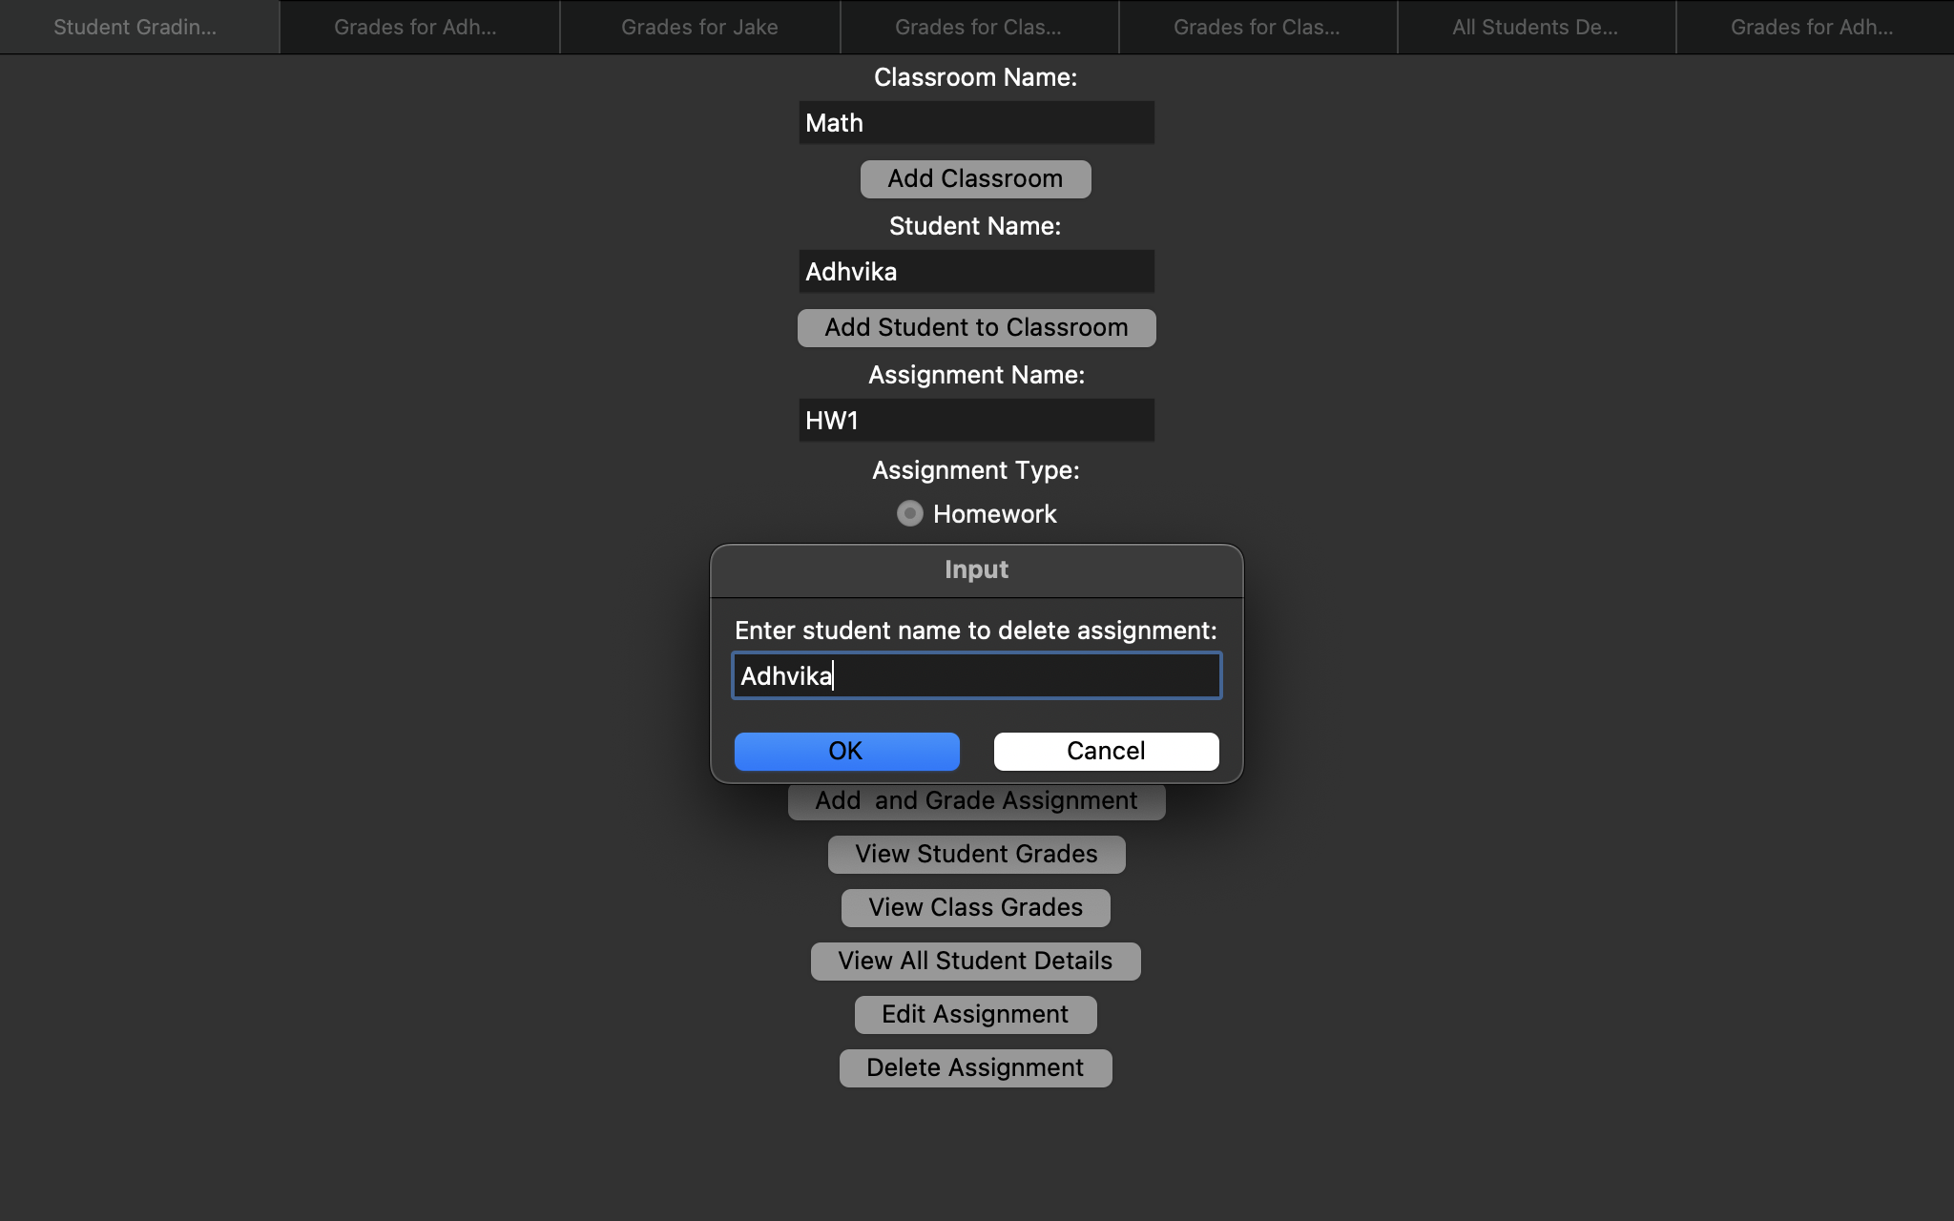

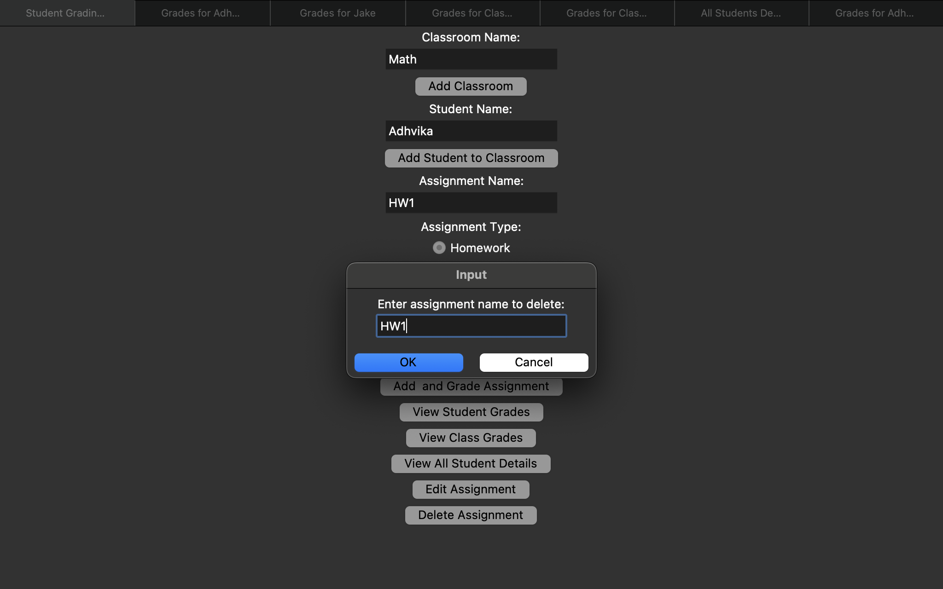

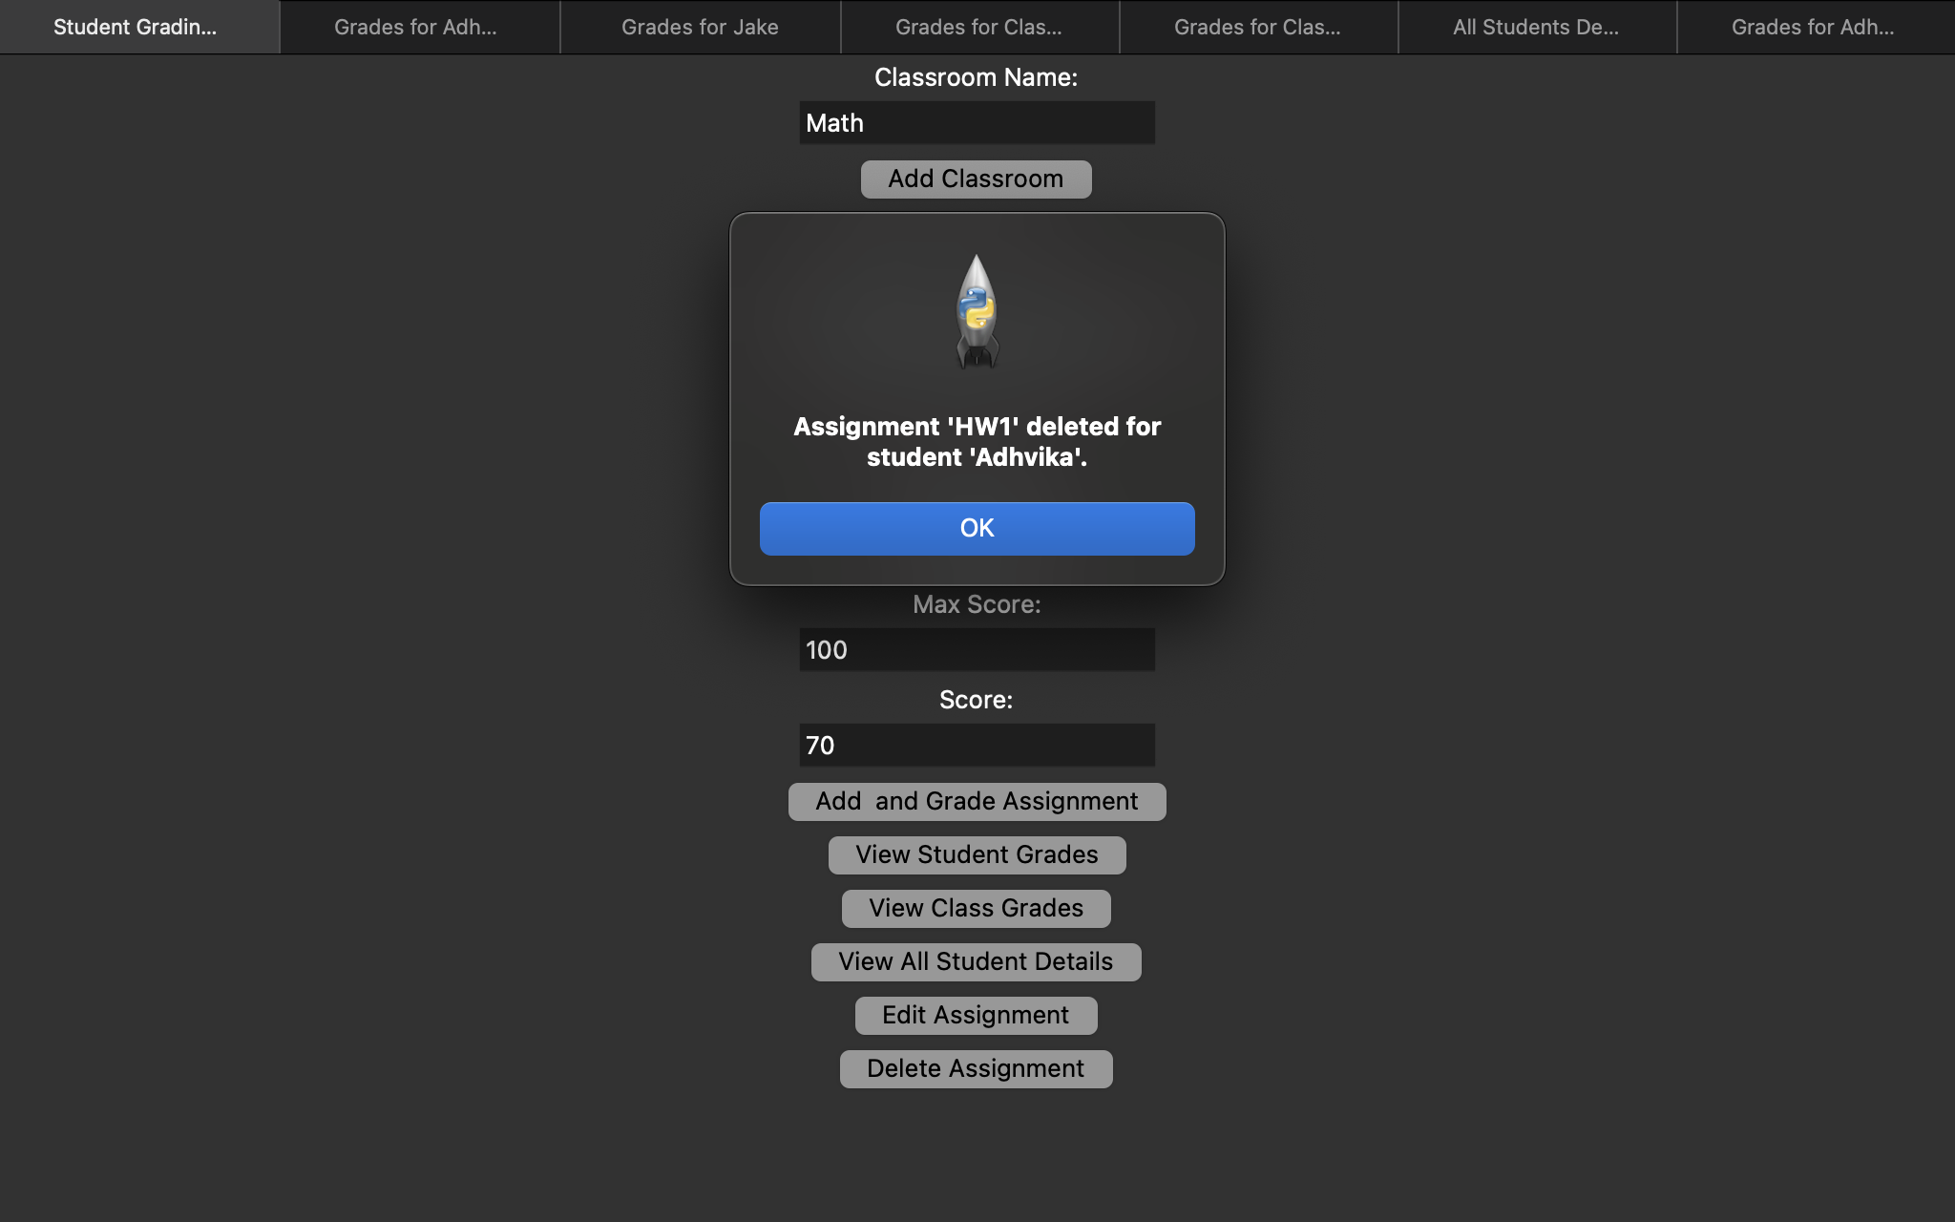

When we click the “OK” button the screen with updated assignments for that Student pops up:

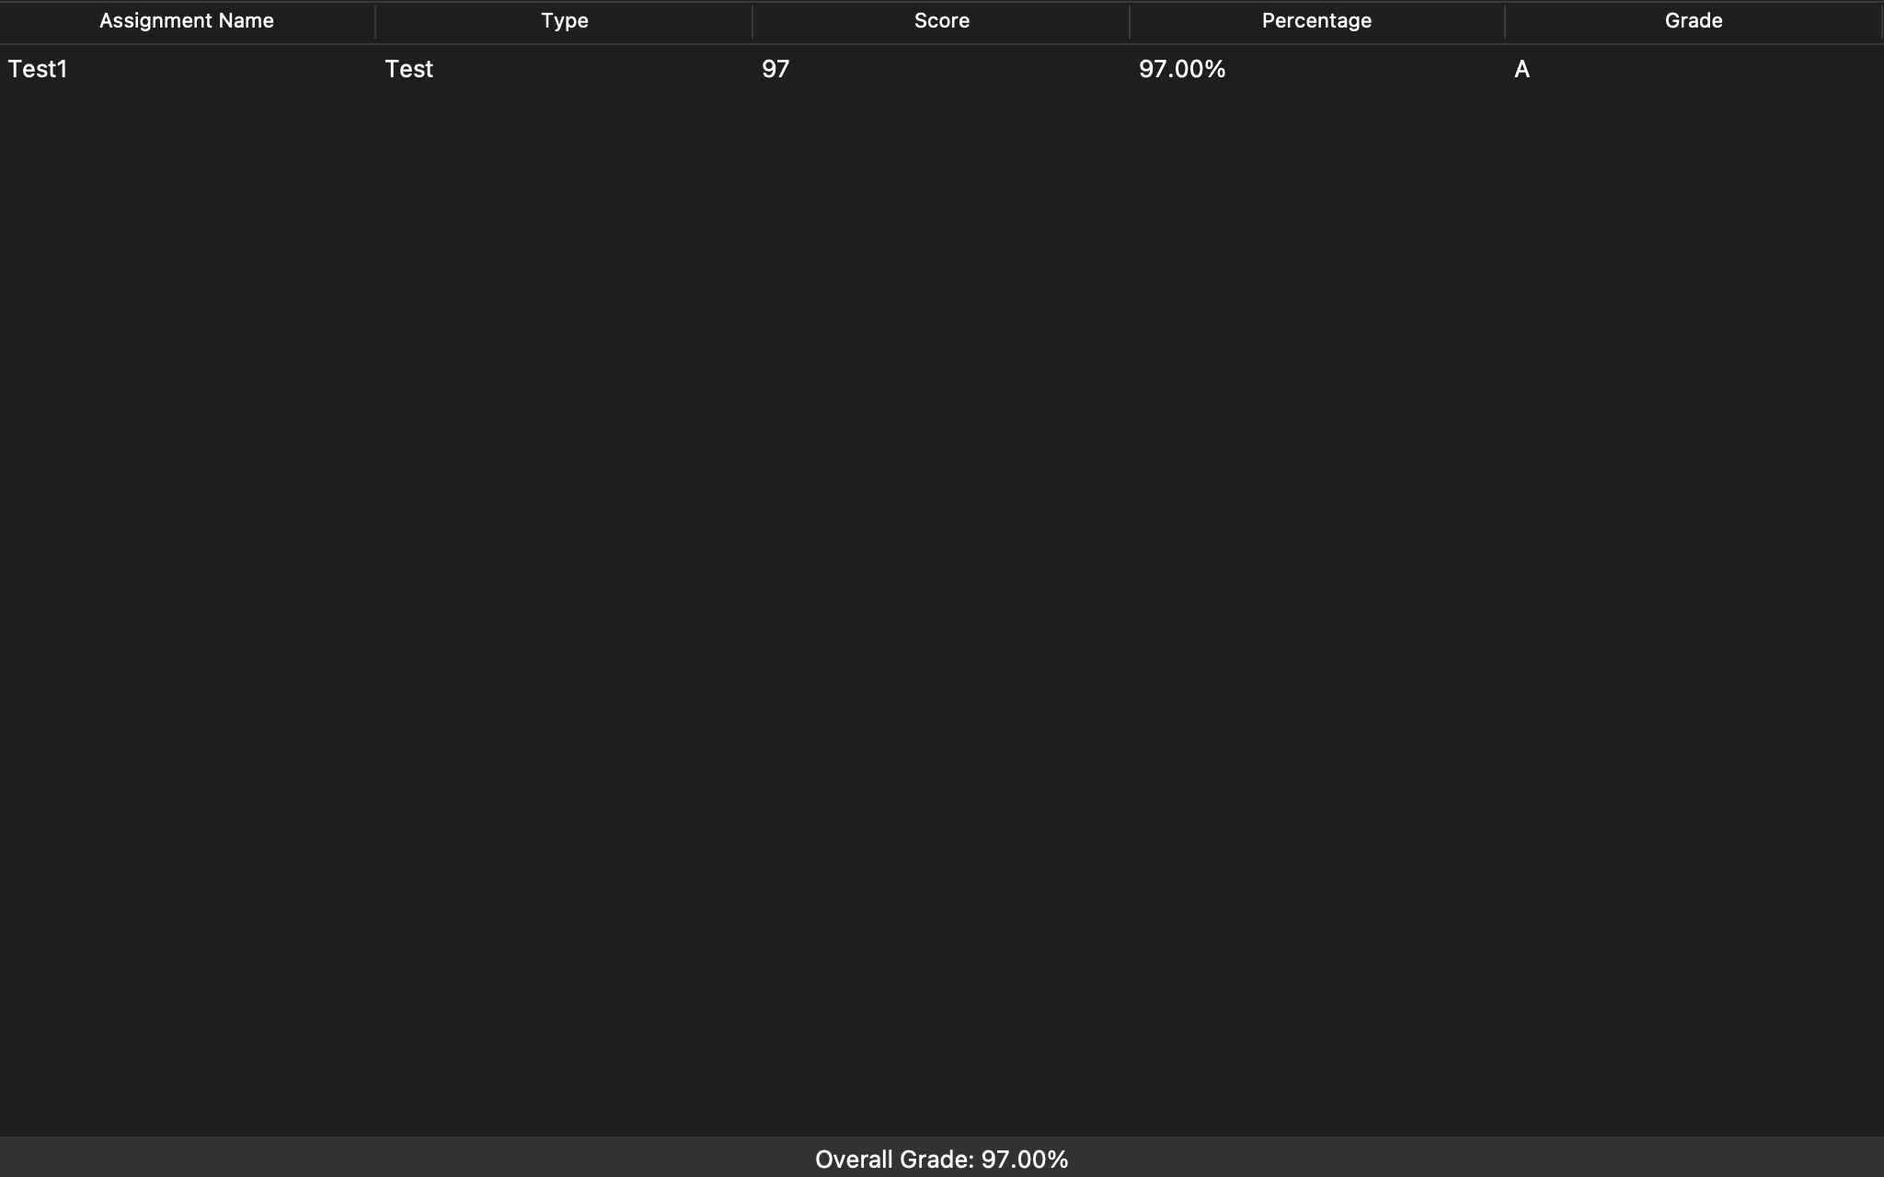

# ***Flowcharts***

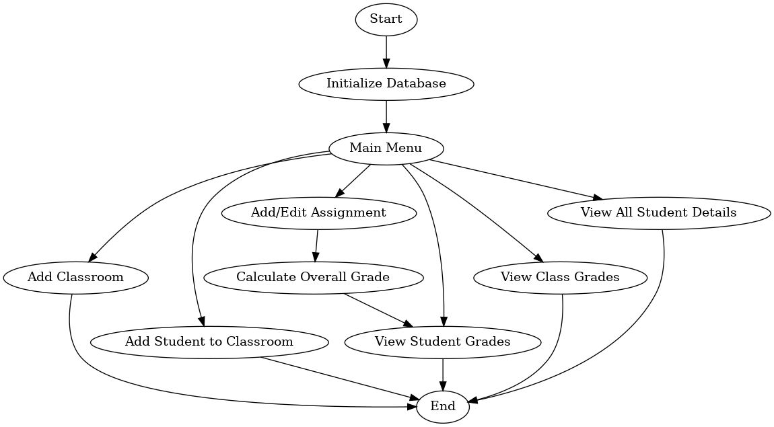

***Initialize Database flowchart***

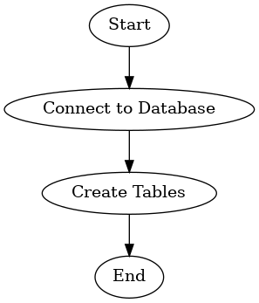

***Add Classroom Flowchart***

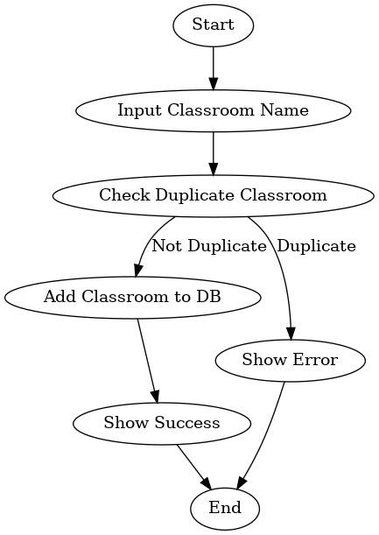

***Add Student flowchart***

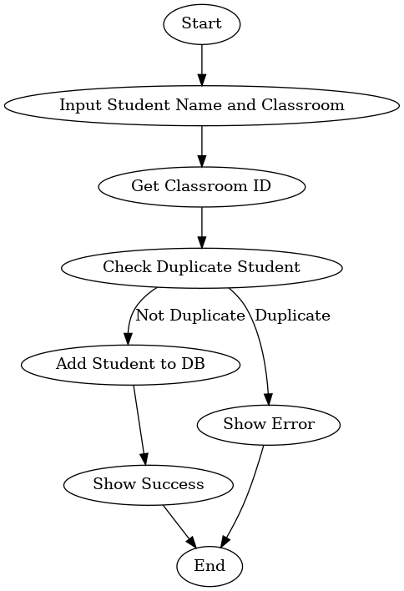

***Add Assignment Flowchart***

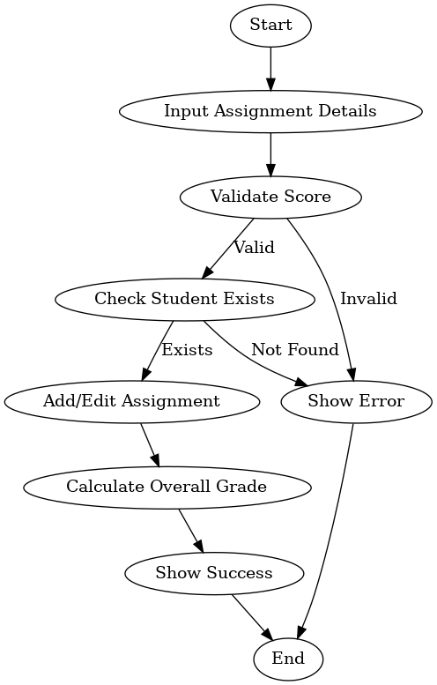

***Edit Assignment Flowchart:***

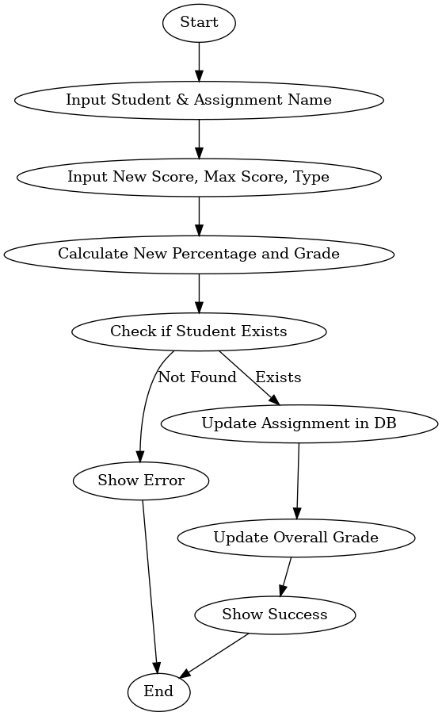

***Delete Assignment Flowchart:***

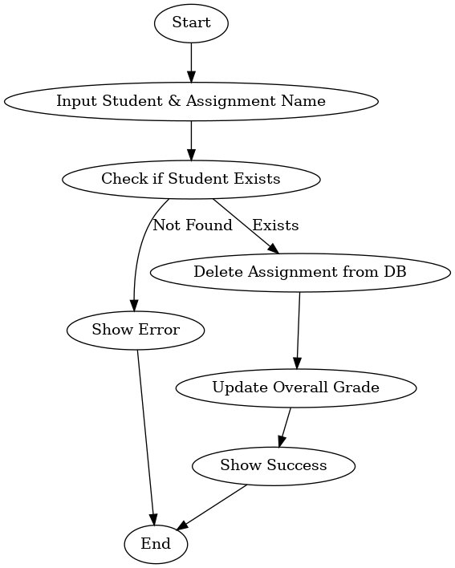

***View Grades Flowchart***

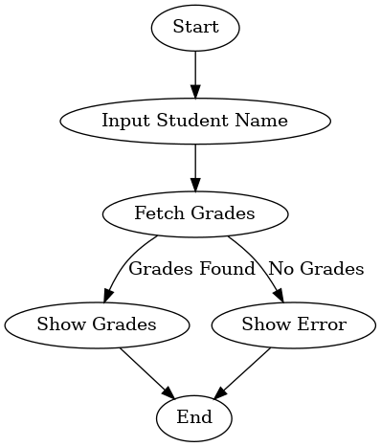

***View All Students Flowchart***

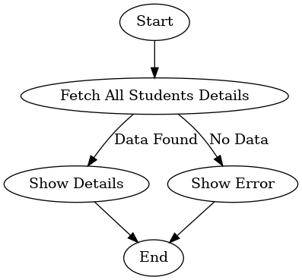

# ***Project Summary:***

## **Student Grading Application**

This project involves developing a student grading application using Python and the Tkinter GUI library. The application manages classrooms, students, and their respective assignments, providing functionalities such as adding classrooms, students, and assignments and calculating overall grades based on predefined weightages. The report delves into the detailed workings of the application, including a comprehensive user manual, flowcharts, and a comparative analysis of Python and other programming languages.

The application leverages Python’s versatility and Tkinter’s simplicity to create an easy-to-use graphical user interface (GUI). The report provides detailed insights into Python’s syntax, data structures, control flow, and error-handling mechanisms. A comparative analysis with other programming languages highlights Python’s readability, flexibility, and lower cost, making it an ideal choice for the project. The complete source code is appended at the end of the report.

# ***History and Overview:***

## **Python**

Python is a high-level, interpreted programming language known for its ease of use and readability. Its syntax allows developers to express concepts with fewer lines of code compared to languages like Java or C++. Python supports multiple programming paradigms, including procedural, object-oriented, and functional programming. With an extensive standard library and a large ecosystem of third-party libraries, Python is widely used for web development, data analysis, artificial intelligence, scientific computing, and more.

History:

Python was developed in the late 1980s by Guido van Rossum and released in 1991. Its design philosophy emphasizes code readability and simplicity, making it easy for beginners while still being powerful for experienced developers. Python has evolved significantly over the years, with Python 2 and Python 3 being the major versions. Python 3, released in 2008, introduced several enhancements and improvements over Python 2.

## **Tkinter**

Tkinter is included with Python, making it a default choice for creating graphical interfaces. It offers an extensive range of widgets like buttons, labels, text boxes, and more. Tkinter’s event-driven architecture allows developers to create interactive applications easily. The toolkit is known for its simplicity and is often used for educational purposes, rapid prototyping, and applications where a lightweight GUI is sufficient.

History:

Tkinter is Python’s standard GUI library, and it provides a fast and easy way to create graphical user interfaces. The library is a thin object-oriented layer on top of the Tcl/Tk GUI toolkit, which was developed in the late 1980s. Tcl (Tool Command Language) and Tk (Toolkit) were created by John Ousterhout as a robust tool for GUI development.

# ***Comparison between languages***

## **1. Readability**

Readability is the ease with which code can be understood, which impacts maintainability.

Python: Python emphasizes code readability with its clean and easy-to-understand syntax. The use of whitespace for indentation encourages a visually consistent structure. Features like list comprehensions, meaningful variable names, and the lack of boilerplate code enhance its readability.

Java: Java's syntax is more verbose, requiring explicit class and method definitions. Its strict typing system and object-oriented structure can add complexity, making the code harder to read for beginners.

C++: C++ allows for low-level memory manipulation, which can lead to complex and hard-to-read code. Its syntax is often verbose and requires a deep understanding of pointers, memory management, and object-oriented principles.

JavaScript: JavaScript, primarily a web programming language, has a concise syntax. However, its dynamic typing and the presence of multiple paradigms (functional, object-oriented) can make understanding complex codebases challenging.

## **2. Writability**

Writeability refers to the ease of writing code and expressing ideas.

Python: Python's simplicity allows developers to write functional code quickly. Its dynamic typing and concise syntax enable rapid development and prototyping.

Java: Java requires more lines of code due to its strict typing and object-oriented design. However, its rich ecosystem and libraries simplify writing enterprise-grade applications.

C++: Writing code in C++ is more challenging due to complex features like pointers, memory management, and multiple inheritance. However, its low-level access provides unmatched control over system resources.

JavaScript: JavaScript is flexible and allows for quick scripting with minimal setup. It is popular for web development due to its ability to manipulate the DOM and its support for various frameworks.

## **3. Reliability**

Reliability is the ability of a programming language to produce robust and error-free code.

Python: Python's dynamic typing and lack of compile-time type checking can lead to runtime errors. However, its extensive libraries and frameworks, along with modern testing tools, improve code reliability.

Java: Java is known for its robustness due to static typing, exception handling, and a vast standard library. Its object-oriented nature ensures better data encapsulation and structure, enhancing reliability.

C++: C++ provides manual memory management, which can lead to issues like memory leaks and undefined behavior. However, experienced developers can write highly reliable code using tools like smart pointers and design patterns.

JavaScript: JavaScript's dynamic nature and asynchronous programming model can make debugging difficult. However, its flexibility allows for rapid iteration and reliable code, provided it's tested thoroughly.

## **4. Cost**

Cost involves the expenses related to development, including tooling, learning curve, and maintenance.

Python: Python is free and open-source, and its simple syntax reduces development time and cost. The extensive standard library and available third-party libraries also reduce the cost of additional tooling.

Java: Java is also free, but developing enterprise-grade applications may require paid enterprise tools. The steep learning curve and verbose syntax can increase development time and cost.

C++: C++ is free but has a steep learning curve. The development cost increases due to the need for specialized tools and the complexity of managing memory manually.

JavaScript: JavaScript is free and available in all major browsers. Its flexible syntax reduces the learning curve, and the vast number of free tools and frameworks makes it cost-effective for web development.

These comparisons highlight the strengths and weaknesses of Python in contrast to Java, C++, and JavaScript, emphasizing Python's readability and writeability, making it an ideal language for rapid development and prototyping.

# ***Illustrations and Explanations of Python features used:***

## **1. Syntax**

Python's syntax is designed to be clean and readable, which makes it distinct from many other languages.

Eg:

def __del__(self):

self.conn.close()

In the example above, Python uses indentation to define the function body, making the code concise and readable.

## **2. Control Structures**

Python offers various control structures, including conditional statements and loops.

Eg:

Conditional statement: if-else statement, nested if statement

if num_homework_assignments > 0 and num_tests == 0:

overall_grade = avg_homework

elif num_tests > 0 and num_homework_assignments == 0:

overall_grade = avg_test

else:

overall_grade = 0.7 * avg_homework + 0.3 * avg_test

def calculate_letter_grade(percentage):

if percentage >= 90:

return 'A'

elif percentage >= 80:

return 'B'

elif percentage >= 70:

return 'C'

elif percentage >= 60:

return 'D'

else:

return 'F'

Loops: for loop used

for student_name, overall_grade in students:

tree.insert("", "end", values=(student_name, f"{overall_grade:.2f}%"))

## **3. Data Structures**

Python supports a variety of built-in data structures, such as lists, dictionaries, sets, and tuples.

## **4. I/O**

Python provides simple mechanisms for input and output operations.

Eg:

Print Statement:

student_id = self.cursor.fetchone()

print(student_id)

Printing formatted output:

self.conn.commit()

messagebox.showinfo("Info", f"Classroom '{class_name}' added.")

## **5. Parameter Passing Methods**

Python uses pass-by-object-reference semantics, which means the actual object is passed to functions.

Eg:

def calculate_letter_grade(percentage):

if percentage >= 90:

return 'A'

elif percentage >= 80:

return 'B'

elif percentage >= 70:

return 'C'

elif percentage >= 60:

return 'D'

else:

return 'F'

## **6. Scope Rules**

Python uses the LEGB (Local, Enclosing, Global, Built-in) rule to determine the scope of variables.

## **7. Stack/Heap - Constructors/Destructors**

Python uses automatic memory management, and objects are allocated on the heap.

Eg:

Constructor:

def __init__(self, root):

self.root = root

self.root.title("Student Grading System")

self.conn = sqlite3.connect('school.db')

self.cursor = self.conn.cursor()

Destructor:

def __del__(self):

self.conn.close()

## **8. Error Handling Procedures**

Python handles errors through the use of try-except blocks.

Eg:

This handles the error of a negative score entered or score larger than max score:

try:

max_score = int(self.max_score_entry.get())

score = int(self.score_entry.get())

if score < 0 or score > max_score:

messagebox.showerror("Error", "Score has to be between 0 and max score.")

return

percentage = (score / max_score) * 100

letter_grade = calculate_letter_grade(percentage)

except ValueError:

messagebox.showerror("Error", "Please enter valid numbers for score and max score.")

return

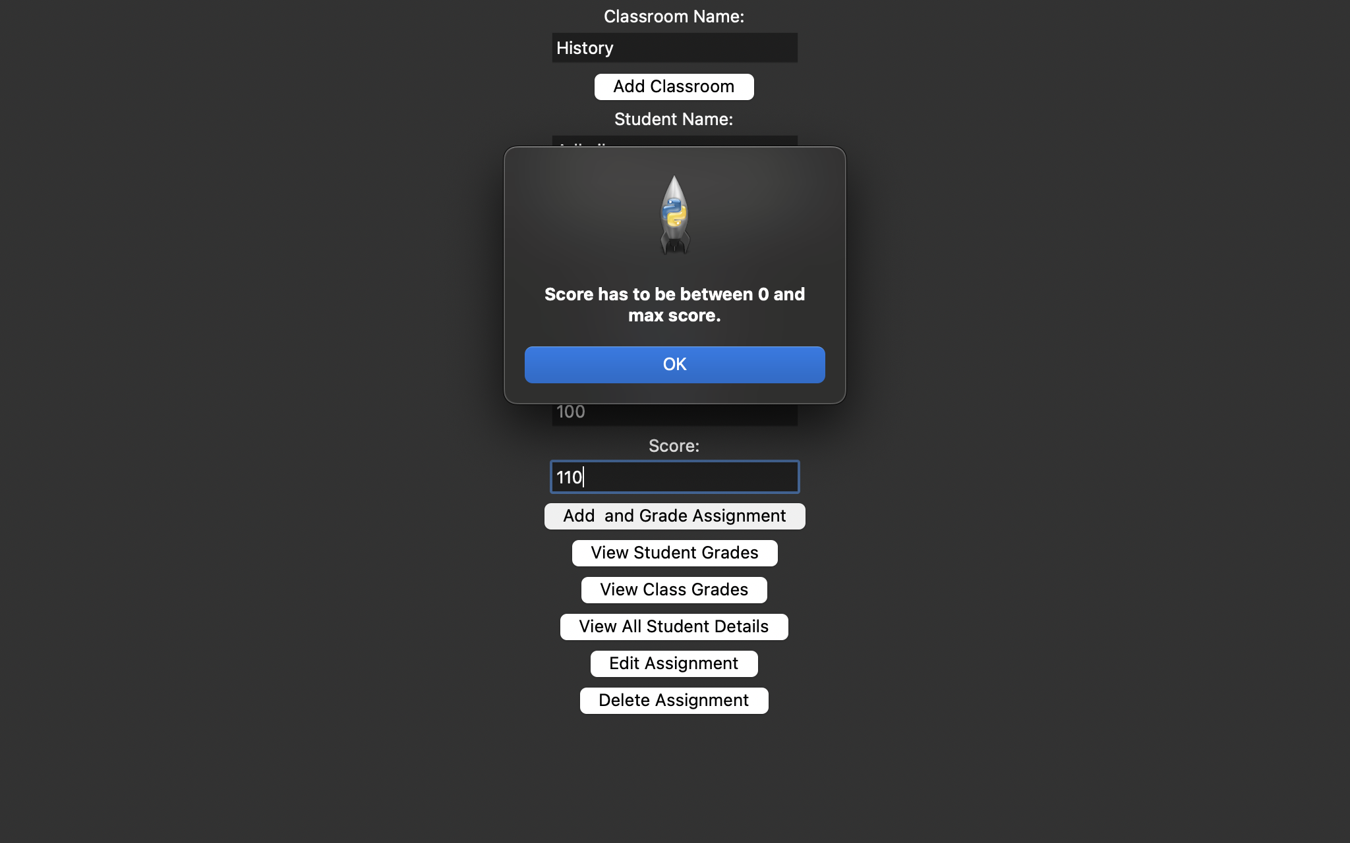

This handles the error of duplicate class name:

if class_name:

try:

self.cursor.execute('INSERT INTO classrooms (name) VALUES (?)', (class_name,))

self.conn.commit()

messagebox.showinfo("Info", f"Classroom '{class_name}' added.")

except sqlite3.IntegrityError:

messagebox.showerror("Error", "Classroom already exists.")

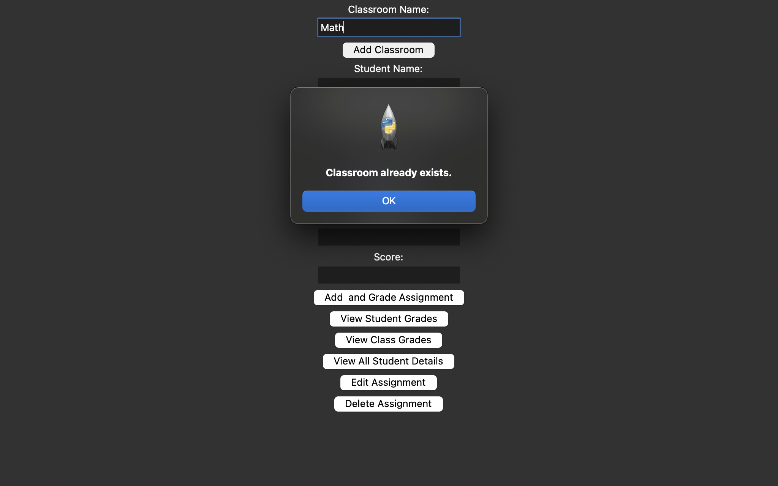

This handles entering a student in a class that doesn’t exist, ie. If we try directly adding a student to a class before actually creating that class.

It also tells us if a particular student has already been added to a class and thus doesn’t duplicate entries.

if classroom_id:

try:

self.cursor.execute('INSERT INTO students (name, classroom_id) VALUES (?, ?)', (student_name, classroom_id[0]))

self.conn.commit()

messagebox.showinfo("Info", f"Student '{student_name}' added to classroom '{class_name}'.")

except sqlite3.IntegrityError:

messagebox.showerror("Error", f"Student '{student_name}' already exists in classroom '{class_name}'.")

else:

messagebox.showerror("Error", "Classroom not found.")

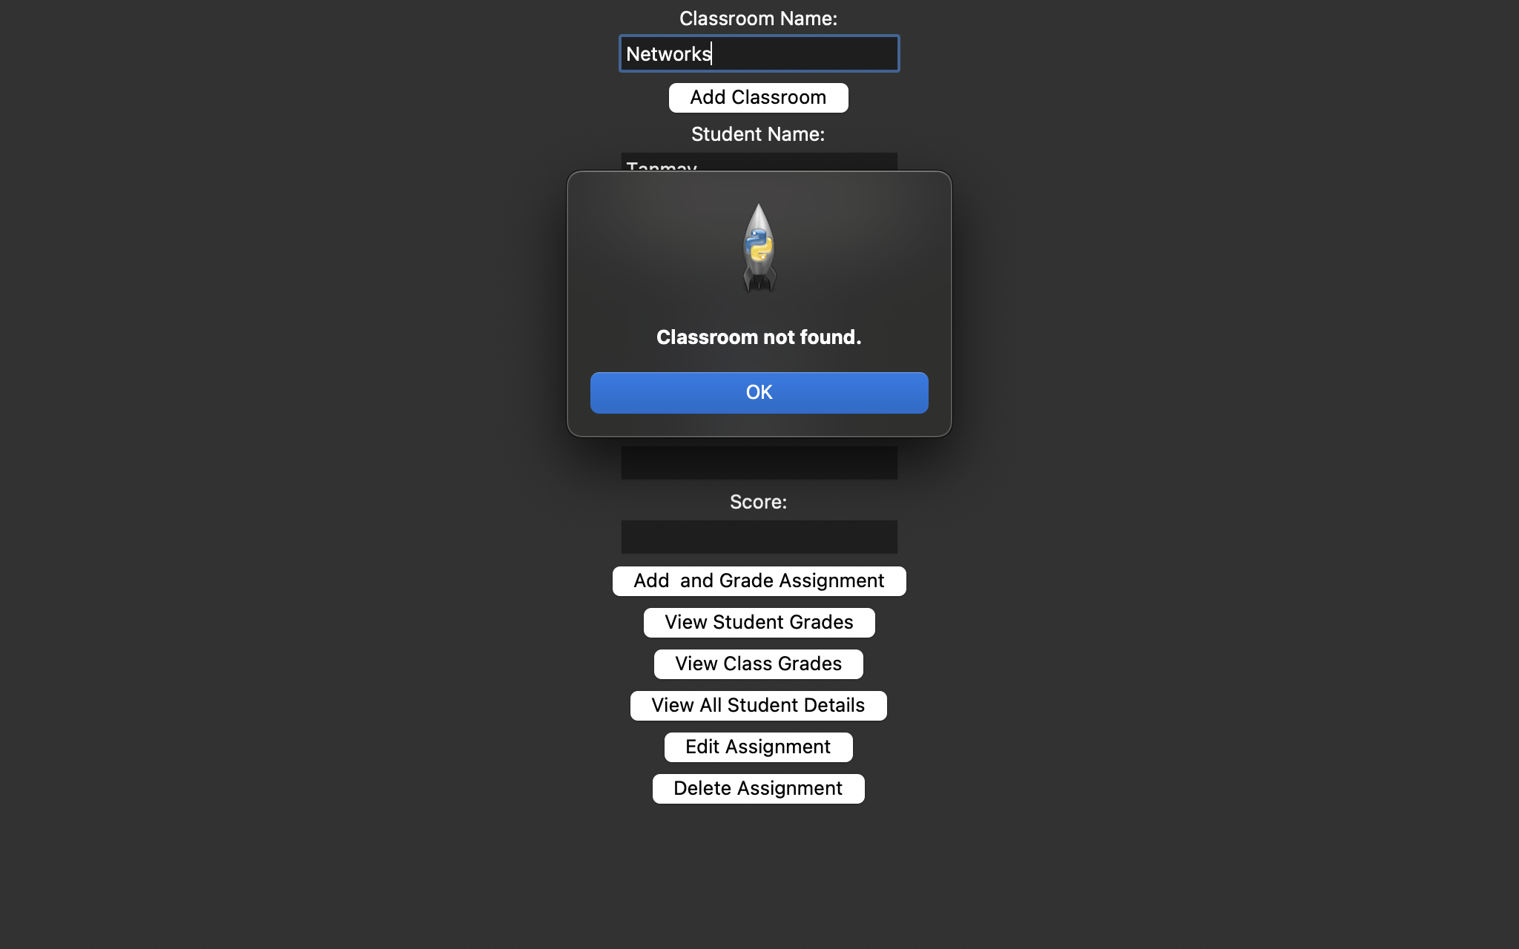

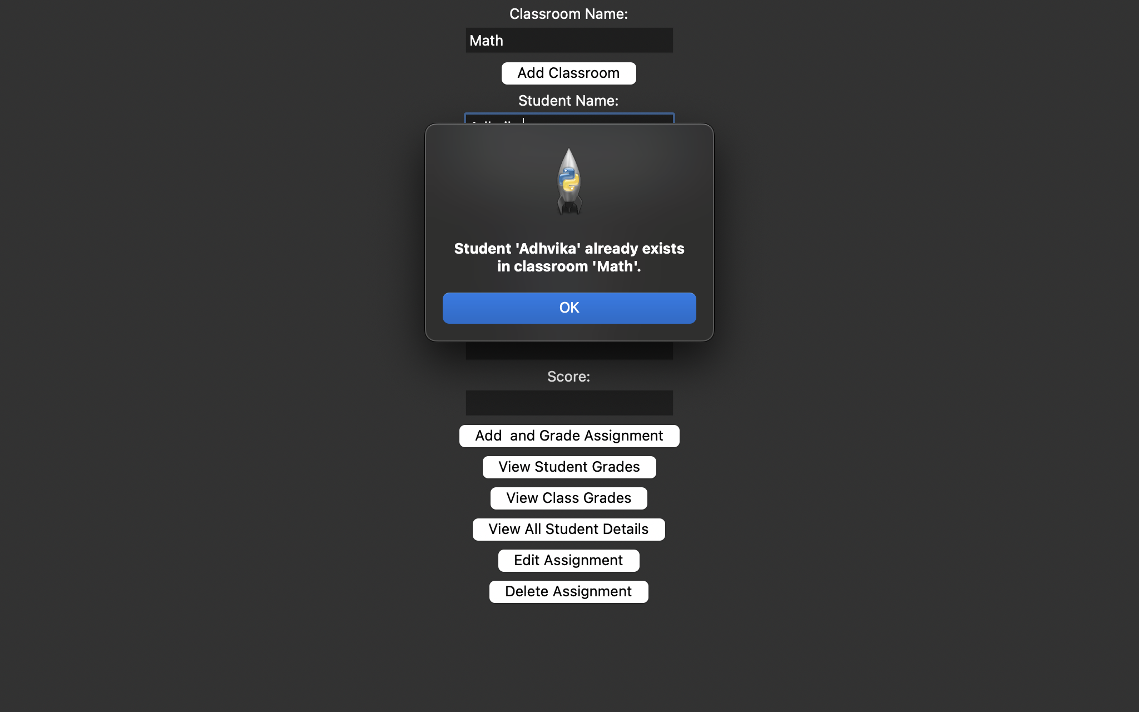

This handles the event that if for a student there is only Test or only Homework grades then the Overall Grade becomes the average of either the test scores or the homework scores, whichever of the two are existing

There is also a formula for the weightage of the Homework assignments to be 70% and that of the Tests to be 30%

if num_homework_assignments > 0 and num_tests == 0:

overall_grade = avg_homework

elif num_tests > 0 and num_homework_assignments == 0:

overall_grade = avg_test

else:

overall_grade = 0.7 * avg_homework + 0.3 * avg_test



While grading and adding an assignment of a particular student, if we directly jump to the add assignment button without first adding a class and then adding a student to it, we get a message that tells us the student isn’t found:

if student_id:

self.cursor.execute('''

INSERT INTO assignments (name, max_score, score, percentage, letter_grade, assignment_type, student_id)

VALUES (?, ?, ?, ?, ?, ?, ?)''',

(assignment_name, max_score, score, percentage, letter_grade, assignment_type, student_id[0]))

self.conn.commit()

self.calculate_overall_grade(student_id[0])

messagebox.showinfo("Info", f"Assignment '{assignment_name}' added/edited for student '{student_name}'. Grade: {letter_grade} ({percentage:.2f}%)")

else:

messagebox.showerror("Error", "Student not found.")

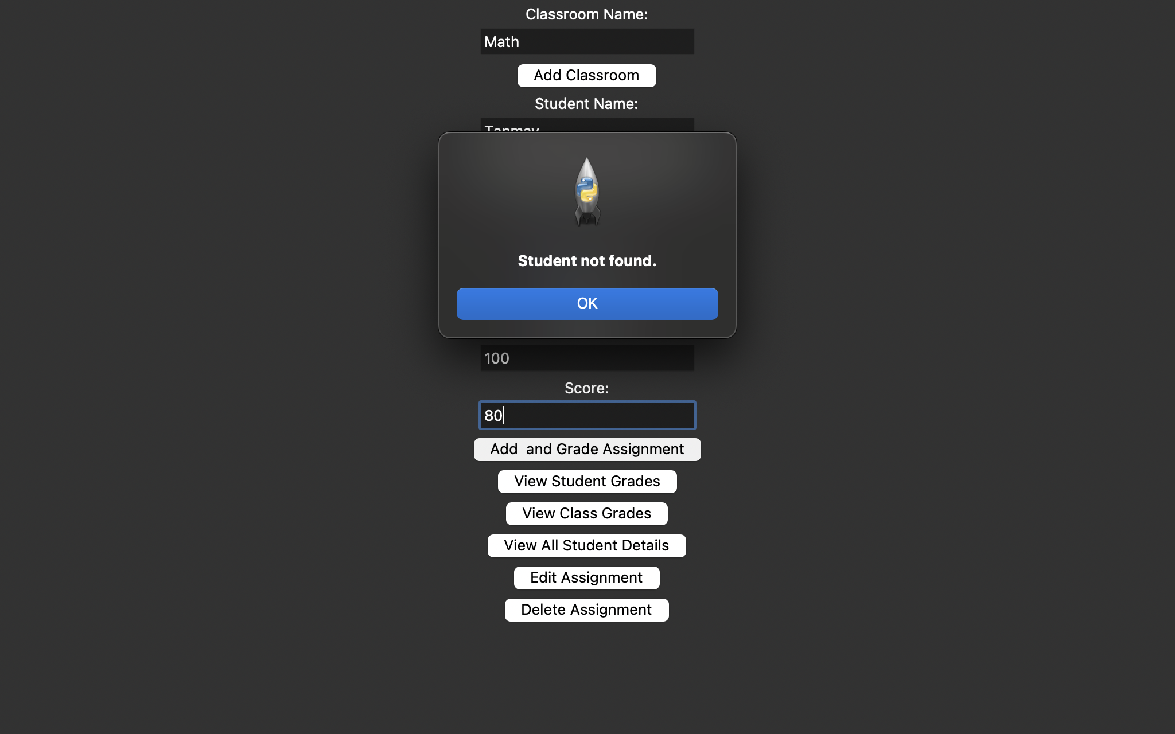

## **9. Data Abstraction**

Data abstraction in Python is a key concept of object-oriented programming (OOP) that focuses on defining abstract entities and hiding implementation details. It simplifies the interface for the user by only showing the relevant details and hiding the internal complexity. It is achieved using classes and abstract classes.

Eg:

Class App, Assignment, Student and Classroom classes exit in my program

class App:

def __init__(self, root):

self.root = root

self.root.title("Student Grading System")

self.conn = sqlite3.connect('school.db')

self.cursor = self.conn.cursor()

class Assignment:

def __init__(self, name, max_score):

self.name = name

self.max_score = max_score

class Student:

def __init__(self, name):

self.name = name

self.assignments = {}

def add_assignment(self, assignment, score):

if 0 <= score <= assignment.max_score:

self.assignments[assignment.name] = score

else:

raise ValueError("Score out of range")

class Classroom:

def __init__(self, name):

self.name = name

self.students = {}

def add_student(self, student_name):

self.students[student_name] = Student(student_name)

def get_student(self, student_name):

return self.students.get(student_name)

# ***Code:***

## **Python and Tkinter GUI**

import tkinter as tk

from tkinter import ttk, messagebox, Toplevel, simpledialog, StringVar, Radiobutton

import sqlite3

def init_db():

conn = sqlite3.connect('school.db')

c = conn.cursor()

c.execute('''

CREATE TABLE IF NOT EXISTS classrooms (

id INTEGER PRIMARY KEY,

name TEXT UNIQUE NOT NULL

)

''')

c.execute('''

CREATE TABLE IF NOT EXISTS students (

id INTEGER PRIMARY KEY,

name TEXT NOT NULL,

classroom_id INTEGER NOT NULL,

overall_grade REAL,

FOREIGN KEY (classroom_id) REFERENCES classrooms (id),

UNIQUE(name, classroom_id)

)

''')

c.execute('''

CREATE TABLE IF NOT EXISTS assignments (

id INTEGER PRIMARY KEY,

name TEXT NOT NULL,

max_score INTEGER NOT NULL,

score INTEGER NOT NULL,

percentage REAL,

letter_grade TEXT,

assignment_type TEXT NOT NULL,

student_id INTEGER NOT NULL,

FOREIGN KEY (student_id) REFERENCES students (id)

)

''')

conn.commit()

conn.close()

def calculate_letter_grade(percentage):

if percentage >= 90:

return 'A'

elif percentage >= 80:

return 'B'

elif percentage >= 70:

return 'C'

elif percentage >= 60:

return 'D'

else:

return 'F'

class App:

def __init__(self, root):

self.root = root

self.root.title("Student Grading System")

self.conn = sqlite3.connect('school.db')

self.cursor = self.conn.cursor()

tk.Label(root, text="Classroom Name:").pack()

self.class_name_entry = tk.Entry(root)

self.class_name_entry.pack()

tk.Button(root, text="Add Classroom", command=self.add_classroom).pack()

tk.Label(root, text="Student Name:").pack()

self.student_name_entry = tk.Entry(root)

self.student_name_entry.pack()

tk.Button(root, text="Add Student to Classroom", command=self.add_student).pack()

tk.Label(root, text="Assignment Name:").pack()

self.assignment_name_entry = tk.Entry(root)

self.assignment_name_entry.pack()

tk.Label(root, text="Assignment Type:").pack()

self.assignment_type_var = StringVar(value="Homework")

Radiobutton(root, text="Homework", variable=self.assignment_type_var, value="Homework").pack()

Radiobutton(root, text="Test", variable=self.assignment_type_var, value="Test").pack()

tk.Label(root, text="Max Score:").pack()

self.max_score_entry = tk.Entry(root)

self.max_score_entry.pack()

tk.Label(root, text="Score:").pack()

self.score_entry = tk.Entry(root)

self.score_entry.pack()

tk.Button(root, text="Add and Grade Assignment", command=self.add_edit_assignment).pack()

tk.Button(root, text="View Student Grades", command=self.view_grades).pack()

tk.Button(root, text="View Class Grades", command=self.view_class_grades).pack()

tk.Button(root, text="View All Student Details", command=self.view_all_students).pack()

tk.Button(root, text="Edit Assignment", command=self.edit_assignment).pack()

tk.Button(root, text="Delete Assignment", command=self.delete_assignment).pack()

def view_all_students(self):

self.cursor.execute('''

SELECT c.name AS classroom_name, s.name AS student_name, a.name AS assignment_name,

a.assignment_type, a.score, a.max_score, a.percentage, a.letter_grade, s.overall_grade

FROM classrooms c

JOIN students s ON c.id = s.classroom_id

LEFT JOIN assignments a ON s.id = a.student_id

ORDER BY c.name, s.name

''')

rows = self.cursor.fetchall()

if rows:

details_window = Toplevel(self.root)

details_window.title("All Students Details")

tree = ttk.Treeview(details_window, columns=("Classroom", "Student", "Assignment", "Type", "Score", "Percentage", "Grade", "Overall Grade"), show="headings")

tree.heading("Classroom", text="Classroom")

tree.heading("Student", text="Student")

tree.heading("Assignment", text="Assignment")

tree.heading("Type", text="Type")

tree.heading("Score", text="Score")

tree.heading("Percentage", text="Percentage")

tree.heading("Grade", text="Grade")

tree.heading("Overall Grade", text="Overall Grade")

tree.pack(fill="both", expand=True)

for classroom_name, student_name, assignment_name, assignment_type, score, max_score, percentage, letter_grade, overall_grade in rows:

percentage_str = f"{percentage:.2f}%" if percentage is not None else "N/A"

score_str = score if score is not None else "N/A"

max_score_str = max_score if max_score is not None else "N/A"

grade_str = letter_grade if letter_grade else "N/A"

assignment_str = assignment_name if assignment_name else "N/A"

overall_grade_str = f"{overall_grade:.2f}%" if overall_grade is not None else "N/A"

tree.insert("", "end", values=(classroom_name, student_name, assignment_str, assignment_type, score_str, max_score_str, percentage_str, grade_str, overall_grade_str))

else:

messagebox.showinfo("Info", "No data found.")

def calculate_overall_grade(self, student_id):

total_homework_score = 0

num_homework_assignments = 0

total_test_score = 0

num_tests = 0

self.cursor.execute('''

SELECT assignment_type, score, max_score

FROM assignments

WHERE student_id = ?

''', (student_id,))

assignments = self.cursor.fetchall()

for assignment_type, score, max_score in assignments:

if assignment_type == "Homework":

total_homework_score += (score / max_score) * 100

num_homework_assignments += 1

elif assignment_type == "Test":

total_test_score += (score / max_score) * 100

num_tests += 1

avg_homework = total_homework_score / num_homework_assignments if num_homework_assignments > 0 else 0

avg_test = total_test_score / num_tests if num_tests > 0 else 0

if num_homework_assignments > 0 and num_tests == 0:

overall_grade = avg_homework

elif num_tests > 0 and num_homework_assignments == 0:

overall_grade = avg_test

else:

overall_grade = 0.7 * avg_homework + 0.3 * avg_test

# if avg_homework is not None and avg_test is not None:

# overall_grade = 0.7 * avg_homework + 0.3 * avg_test

# elif avg_homework is not None:

# overall_grade = avg_homework

# elif avg_test is not None:

# overall_grade = avg_test

# else:

# overall_grade = None

self.cursor.execute('''

UPDATE students

SET overall_grade = ?

WHERE id = ?

''', (overall_grade, student_id))

self.conn.commit()

def add_edit_assignment(self):

student_name = self.student_name_entry.get()

assignment_name = self.assignment_name_entry.get()

assignment_type = self.assignment_type_var.get()

try:

max_score = int(self.max_score_entry.get())

score = int(self.score_entry.get())

if score < 0 or score > max_score:

messagebox.showerror("Error", "Score has to be between 0 and max score.")

return

percentage = (score / max_score) * 100

letter_grade = calculate_letter_grade(percentage)

except ValueError:

messagebox.showerror("Error", "Please enter valid numbers for score and max score.")

return

self.cursor.execute('SELECT id FROM students WHERE name = ?', (student_name,))

student_id = self.cursor.fetchone()

print(student_id)

if student_id:

self.cursor.execute('''

INSERT INTO assignments (name, max_score, score, percentage, letter_grade, assignment_type, student_id)

VALUES (?, ?, ?, ?, ?, ?, ?)''',

(assignment_name, max_score, score, percentage, letter_grade, assignment_type, student_id[0]))

self.conn.commit()

self.calculate_overall_grade(student_id[0])

messagebox.showinfo("Info", f"Assignment '{assignment_name}' added/edited for student '{student_name}'. Grade: {letter_grade} ({percentage:.2f}%)")

else:

messagebox.showerror("Error", "Student not found.")

def edit_assignment(self):

student_name = simpledialog.askstring("Input", "Enter student name to edit assignment:", parent=self.root)

assignment_name = simpledialog.askstring("Input", "Enter assignment name to edit:", parent=self.root)

if not student_name or not assignment_name:

messagebox.showinfo("Info", "Student name and Assignment name cannot be empty.")

return

new_score = simpledialog.askinteger("Input", "Enter new score:", parent=self.root)

new_max_score = simpledialog.askinteger("Input", "Enter new max score:", parent=self.root)

new_assignment_type = simpledialog.askstring("Input", "Enter new assignment type (Homework/Test):", parent=self.root)

if new_score < 0 or new_score > new_max_score:

messagebox.showerror("Error", "Score must be between 0 and the maximum score.")

return

new_percentage = (new_score / new_max_score) * 100

new_letter_grade = calculate_letter_grade(new_percentage)

self.cursor.execute('SELECT s.id FROM students s WHERE s.name = ?', (student_name,))

student_id = self.cursor.fetchone()

if student_id:

self.cursor.execute('''

UPDATE assignments

SET max_score = ?, score = ?, percentage = ?, letter_grade = ?, assignment_type = ?

WHERE name = ? AND student_id = ?

''', (new_max_score, new_score, new_percentage, new_letter_grade, new_assignment_type, assignment_name, student_id[0]))

self.conn.commit()

self.calculate_overall_grade(student_id[0])

messagebox.showinfo("Info", f"Assignment '{assignment_name}' updated for student '{student_name}'. New Grade: {new_letter_grade} ({new_percentage:.2f}%)")

else:

messagebox.showerror("Error", "Student not found.")

def delete_assignment(self):

student_name = simpledialog.askstring("Input", "Enter student name to delete assignment:", parent=self.root)

assignment_name = simpledialog.askstring("Input", "Enter assignment name to delete:", parent=self.root)

if not student_name or not assignment_name:

messagebox.showinfo("Info", "Student name and Assignment name cannot be empty.")

return

self.cursor.execute('SELECT s.id FROM students s WHERE s.name = ?', (student_name,))

student_id = self.cursor.fetchone()

if student_id:

self.cursor.execute('DELETE FROM assignments WHERE name = ? AND student_id = ?', (assignment_name, student_id[0]))

self.conn.commit()

self.calculate_overall_grade(student_id[0])

messagebox.showinfo("Info", f"Assignment '{assignment_name}' deleted for student '{student_name}'.")

self.view_grades(student_name)

else:

messagebox.showerror("Error", "Student not found.")

def view_grades(self, student_name=None):

if not student_name:

student_name = simpledialog.askstring("Input", "Enter student name to view grades:",

parent=self.root)

if student_name:

self.cursor.execute('''

SELECT a.name, a.assignment_type, a.score, a.percentage, a.letter_grade, s.overall_grade

FROM assignments a

JOIN students s ON a.student_id = s.id

WHERE s.name = ?''', (student_name,))

rows = self.cursor.fetchall()

if rows:

grade_window = Toplevel(self.root)

grade_window.title(f"Grades for {student_name}")

tree = ttk.Treeview(grade_window, columns=("Assignment Name", "Type", "Score", "Percentage", "Grade"), show="headings")

tree.heading("Assignment Name", text="Assignment Name")

tree.heading("Type", text="Type")

tree.heading("Score", text="Score")

tree.heading("Percentage", text="Percentage")

tree.heading("Grade", text="Grade")

tree.pack(fill="both", expand=True)

for name, assignment_type, score, percentage, letter_grade, overall_grade in rows:

tree.insert("", "end", values=(name, assignment_type, score, f"{percentage:.2f}%", letter_grade))

tk.Label(grade_window, text=f"Overall Grade: {overall_grade:.2f}%").pack()

else:

messagebox.showinfo("Info", "No grades found for this student.")

else:

messagebox.showinfo("Info", "Student name cannot be empty.")

def view_class_grades(self):

classroom_name = simpledialog.askstring("Input", "Enter classroom name to view grades:", parent=self.root)

if classroom_name:

self.cursor.execute('SELECT id FROM classrooms WHERE name = ?', (classroom_name,))

classroom_id = self.cursor.fetchone()

if classroom_id:

self.cursor.execute('''

SELECT s.name, s.overall_grade

FROM students s

WHERE s.classroom_id = ?

''', (classroom_id[0],))

students = self.cursor.fetchall()

grade_window = Toplevel(self.root)

grade_window.title(f"Grades for Classroom {classroom_name}")

tree = ttk.Treeview(grade_window, columns=("Student Name", "Overall Grade"), show="headings")

tree.heading("Student Name", text="Student Name")

tree.heading("Overall Grade", text="Overall Grade")

tree.pack(fill="both", expand=True)

if students:

for student_name, overall_grade in students:

overall_grade_str = f"{overall_grade:.2f}%" if overall_grade is not None else "Grade not calculated"

tree.insert("", "end", values=(student_name, overall_grade_str))

else:

tk.Label(grade_window, text="No students found for this classroom.").pack()

else:

messagebox.showinfo("Info", "Classroom not found.")

else:

messagebox.showinfo("Info", "Classroom name cannot be empty.")

def add_classroom(self):

class_name = self.class_name_entry.get()

if class_name:

try:

self.cursor.execute('INSERT INTO classrooms (name) VALUES (?)', (class_name,))

self.conn.commit()

messagebox.showinfo("Info", f"Classroom '{class_name}' added.")

except sqlite3.IntegrityError:

messagebox.showerror("Error", "Classroom already exists.")

def add_student(self):

class_name = self.class_name_entry.get()

student_name = self.student_name_entry.get()

if not class_name or not student_name:

messagebox.showerror("Error", "Classroom and Student names cannot be empty.")

return

self.cursor.execute('SELECT id FROM classrooms WHERE name = ?', (class_name,))

classroom_id = self.cursor.fetchone()

if classroom_id:

try:

self.cursor.execute('INSERT INTO students (name, classroom_id) VALUES (?, ?)', (student_name, classroom_id[0]))

self.conn.commit()

messagebox.showinfo("Info", f"Student '{student_name}' added to classroom '{class_name}'.")

except sqlite3.IntegrityError:

messagebox.showerror("Error", f"Student '{student_name}' already exists in classroom '{class_name}'.")

else:

messagebox.showerror("Error", "Classroom not found.")

def __del__(self):

self.conn.close()

if __name__ == "__main__":

init_db()

root = tk.Tk()

app = App(root)

root.mainloop()

class Assignment:

def __init__(self, name, max_score):

self.name = name

self.max_score = max_score

class Student:

def __init__(self, name):

self.name = name

self.assignments = {}

def add_assignment(self, assignment, score):

if 0 <= score <= assignment.max_score:

self.assignments[assignment.name] = score

else:

raise ValueError("Score out of range")

class Classroom:

def __init__(self, name):

self.name = name

self.students = {}

def add_student(self, student_name):

self.students[student_name] = Student(student_name)

def get_student(self, student_name):

return self.students.get(student_name)

## **Scripting Code-Powershell**

cls

Write-Host "This script will install the Adhvika's Grading Application"

Write-Host "To begin installation, make sure the folder my-grading containing the application has been unzipped in your downloads folder"

Read-Host "I've read and understood this message: Press Enter"

Read-Host "Press enter to install this application..."

cls

C:

cd\

$Dirname="c:\myapp"

if (-NOT (Test-Path $Dirname))

{md myapp}

Copy-Item -Path "$home\Downloads\my-grading" -Destination "c:\myapp" -Recurse

cd myapp

Start-Process -FilePath "c:myapp\my-grading\dist\test.exe" -ArgumentList "/S" -PassThru

$SourceFilePath = "c:\myapp\my-grading\dist\test.exe"

$ShortcutPath = "$home\Desktop\myapp.lnk"

$WScriptObj = New-Object -ComObject ("WScript.Shell")

$shortcut = $WscriptObj.CreateShortcut($ShortcutPath)

$shortcut.TargetPath = $SourceFilePath

$shortcut.Save()

As you can see, I tested my powershell script in the Engineering Lab and it works, the “myapp” icon is made and it works when you click it.

